**Oracle EBS Payables Assignment**

**Date :06th Dec 2024:**

**Each & Every assignment needs to explain with necessary screen shots.**

**Name: Areba Hashmi**

1. **Create an Invoice Standard: [Payment team: Immediate].**
2. Navigate to Oracle EBS Payables > Invoices > Entry
3. Once form is opened, begin filling out header level information.
4. Type, Trading Partner, Supplier Num, Supplier Site, Invoice Date, Invoice Num, Invoice currency, Invoice Amount, GL date, Payment Currency, Terms date, Terms, and Payment method are the mandatory header level fields  
   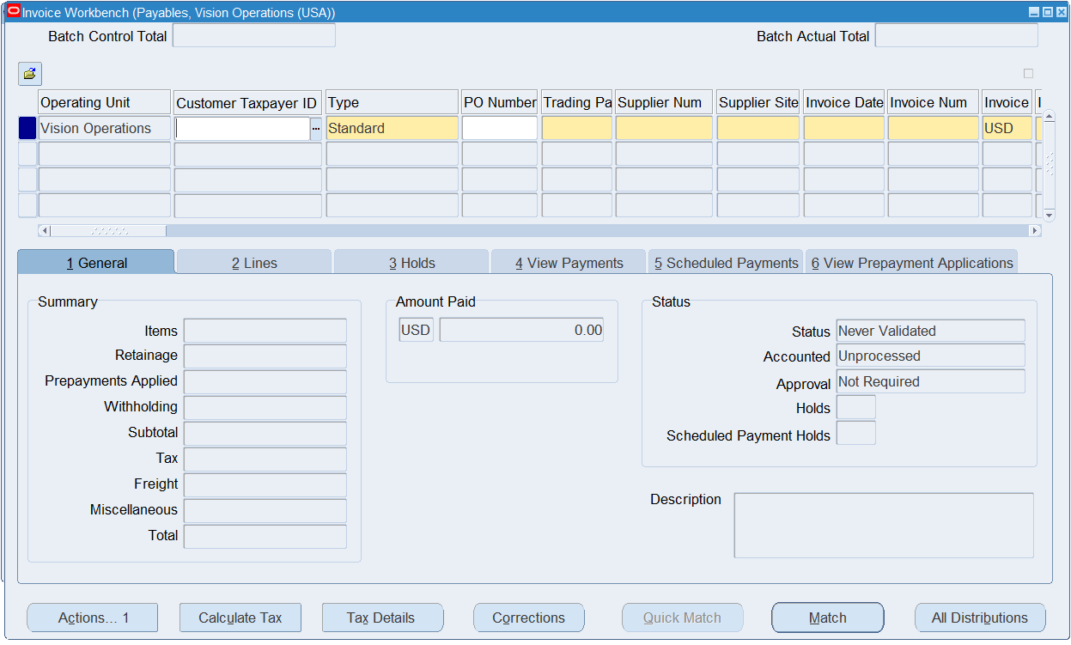
5. Under “Type” select Standard and under “Payment Terms” select Immediate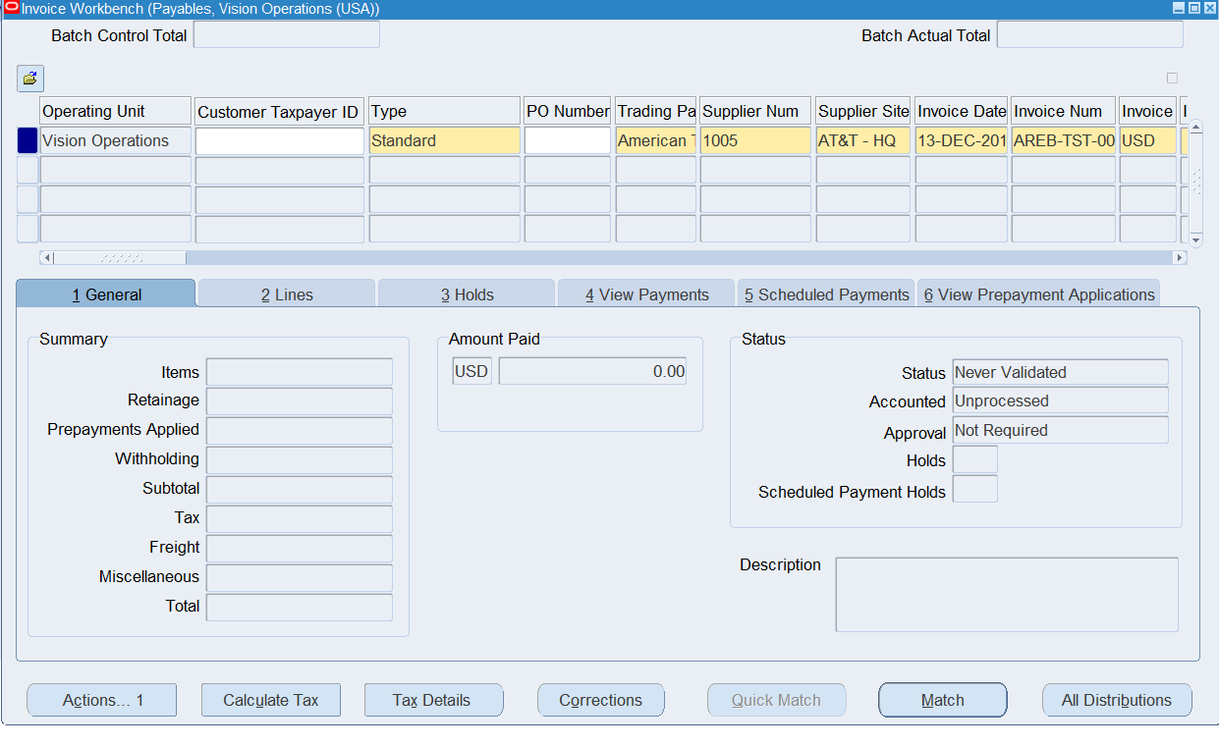

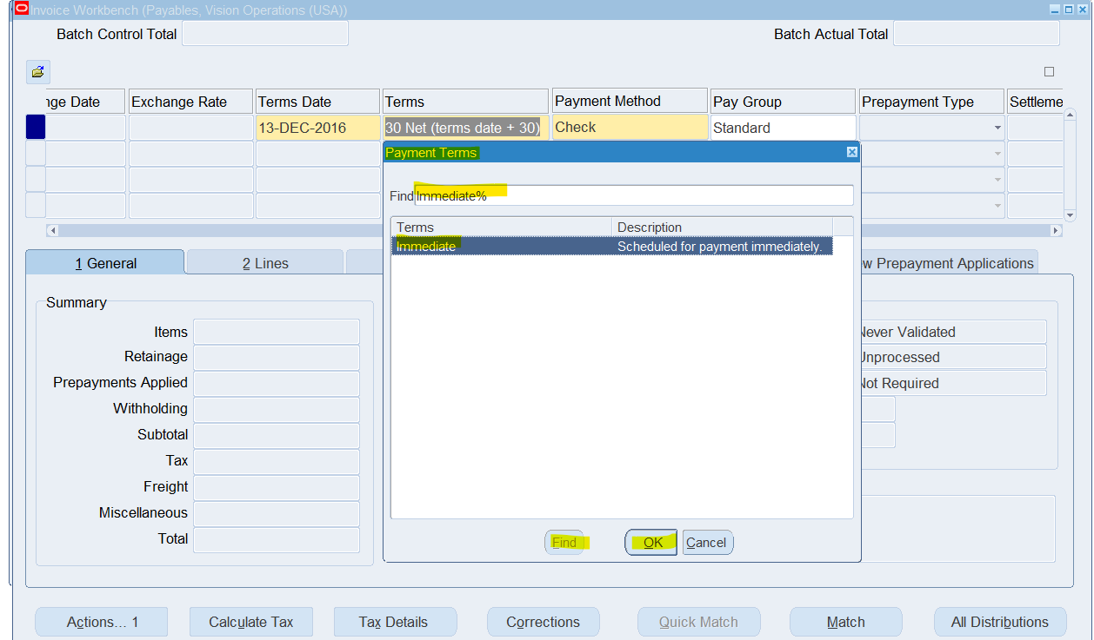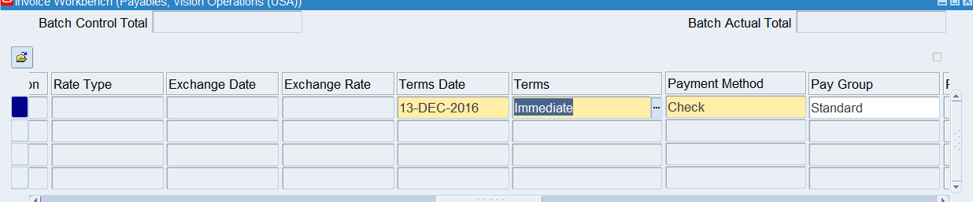

1. SAVE
2. Move on to Lines Table and include the following Mandatory Fields: Item, Amount, GL date. Make sure Amount value in ‘Lines’ matches the Amount value in ‘Header’. Include Distribution Account Value Flexfields. at this point and SAVE.  
   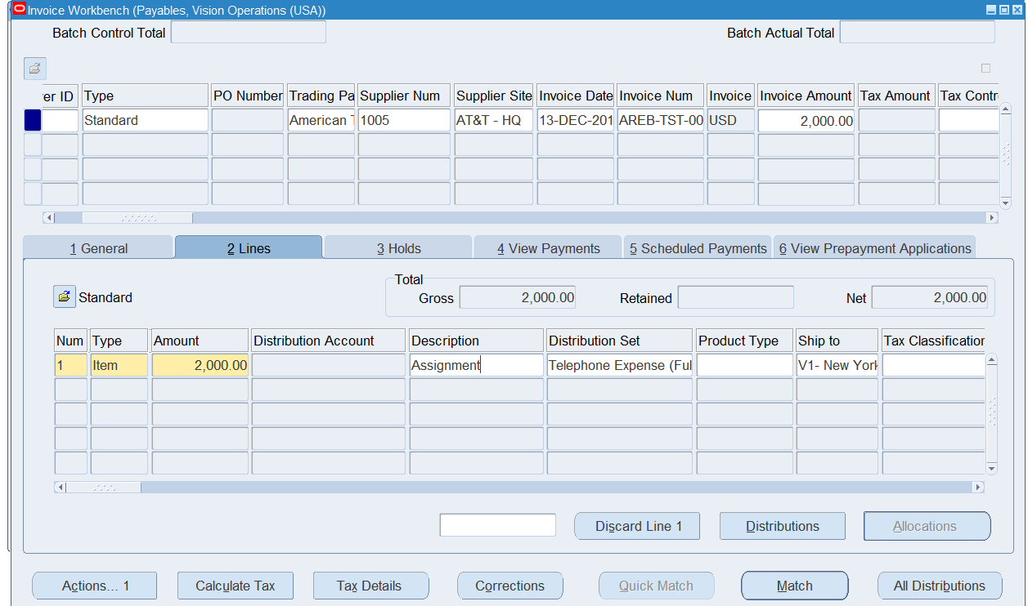

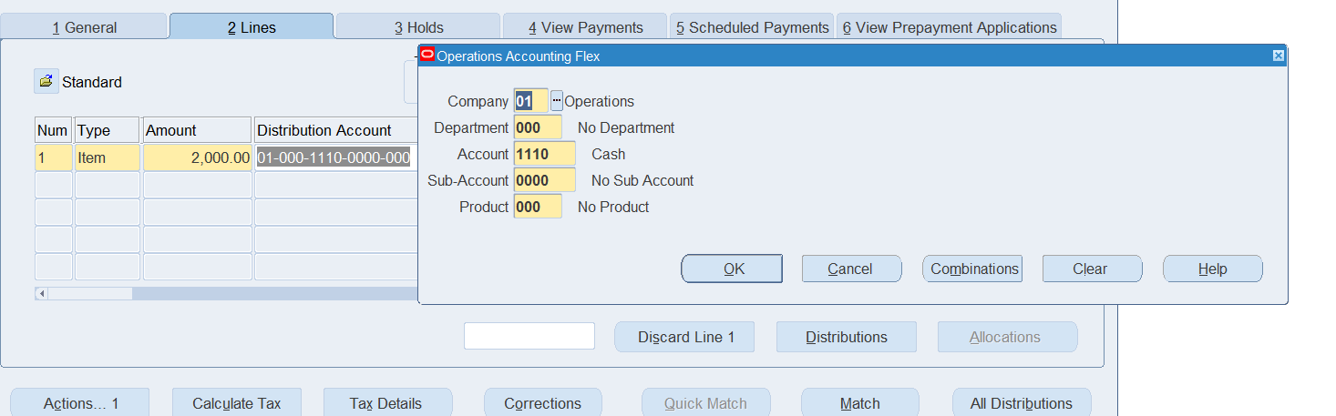

1. Calculate Tax by clicking on the “Calculate Tax” bar at the bottom of the screen.
2. Once the Tax has been added, check to make sure it is also included at the header level.
3. SAVE
4. Now that the total value has been changed, update the “Invoice Amount” at the “Header Level” to reflect the total charge after adding Tax and SAVE.

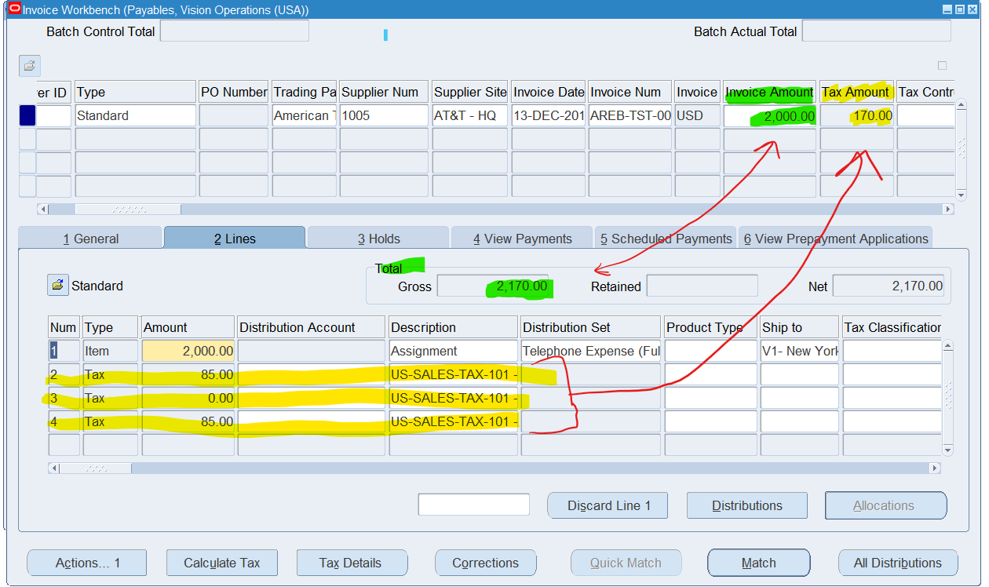

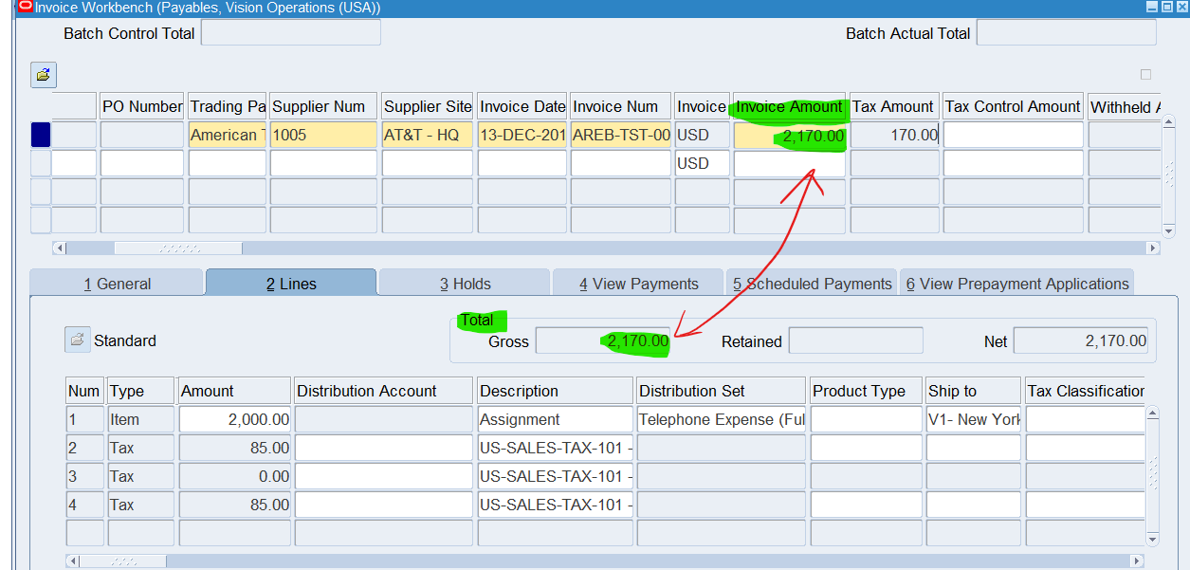

1. Return to the General Ledger Table, ensure that all values are accurate.  
   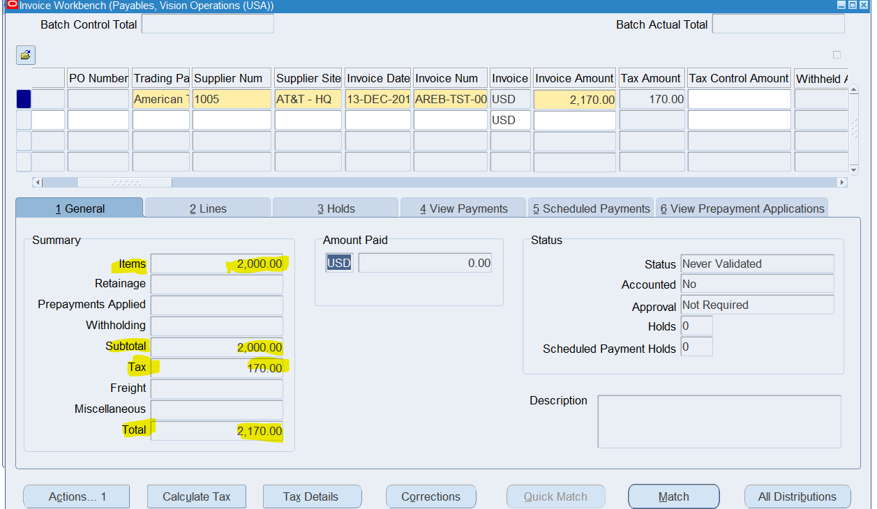
2. **Validate the Invoice:**
   * Validate the invoice you just created to ensure there are no errors and it's ready for payment.
3. Click on the “Actions” at the bottom of screen

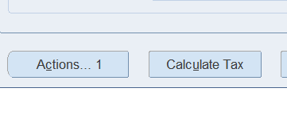

1. Check the “Validate” box before clicking “OK”

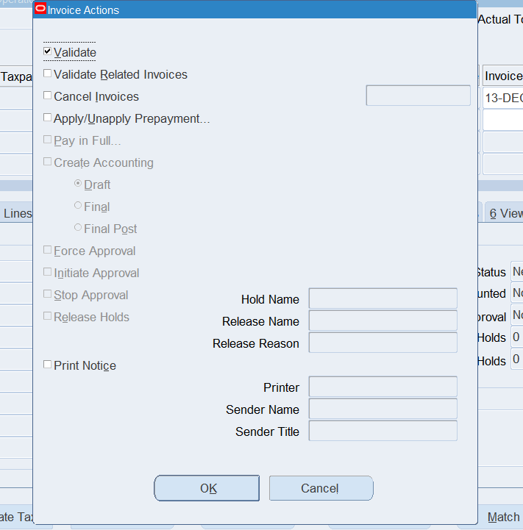

1. The “Status” should now show “Validated” if successful validation has occurred. If it has not, re-check any errors in the values.

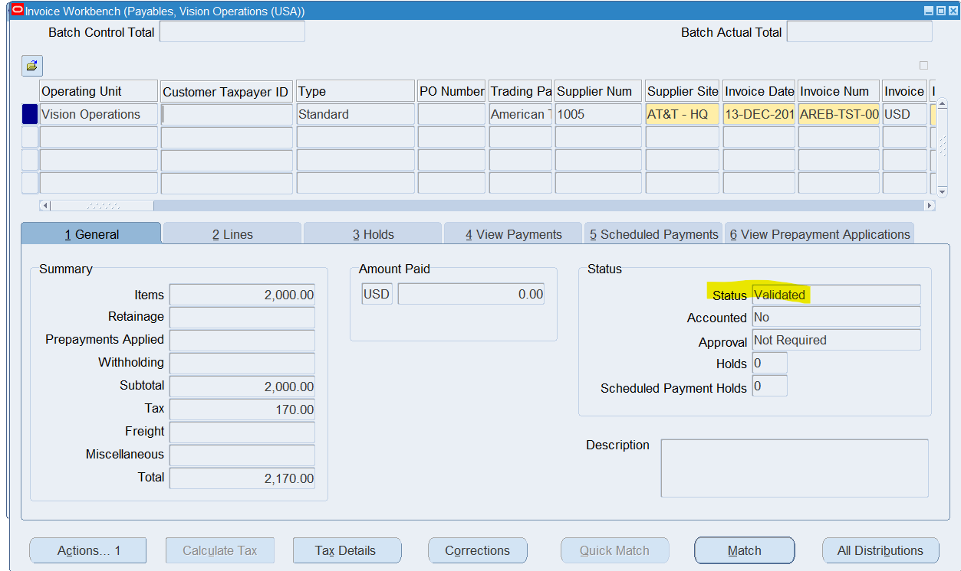

1. **Do Create Accounting & Transfer to General Ledger:**
2. Refer to “Actions” at the bottom of screen



1. Select Checkbox: “Create Accounting”
2. Select “Final Post”
3. Click “OK”

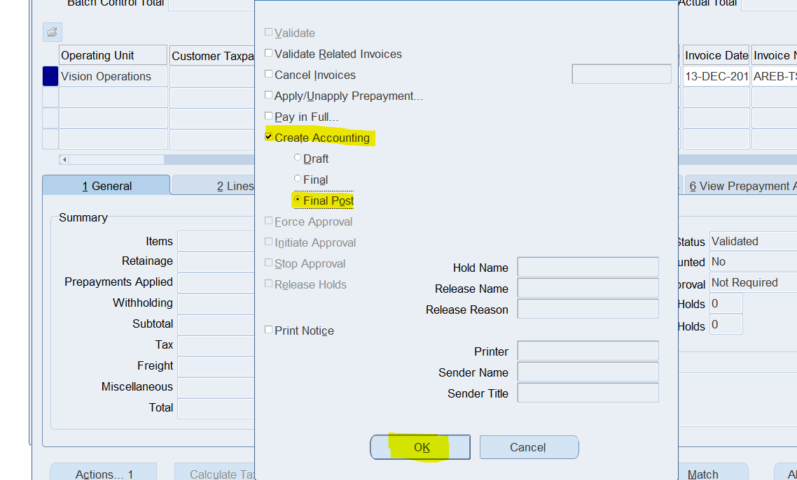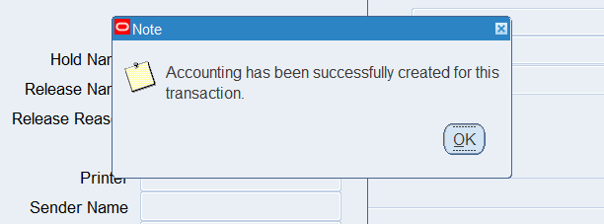

1. The “Accounted” field should now be labeled “Yes”

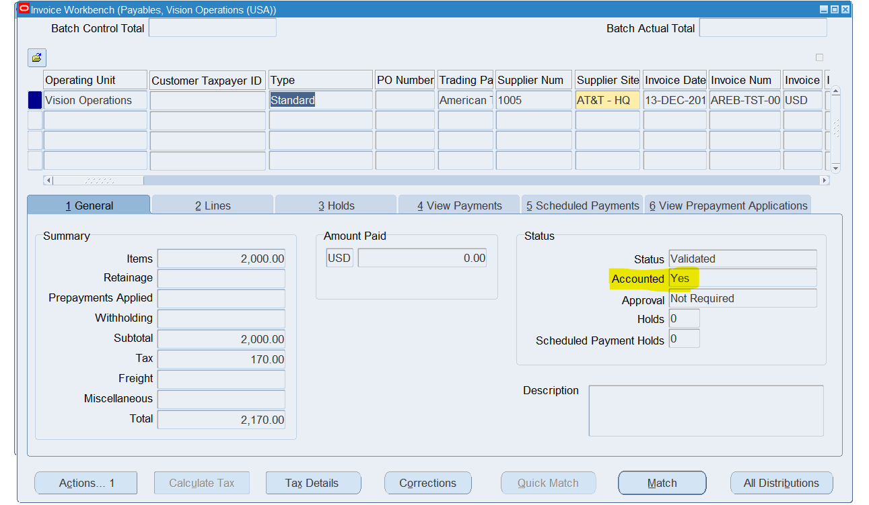

1. SAVE.
2. **Create A debit Memo** (Validate & Create accounting) .. Explain each & every step with screen shot.
3. Navigate to Oracle EBS Payables > Invoices > Entry
4. Once form is opened, begin filling out header level information.
5. Type, Trading Partner, Supplier Num, Supplier Site, Invoice Date, Invoice Num, Invoice currency, Invoice Amount, GL date, Payment Currency, Terms date, Terms, and Payment method are the mandatory header level fields
6. Under “Type” Select “Debit Memo”

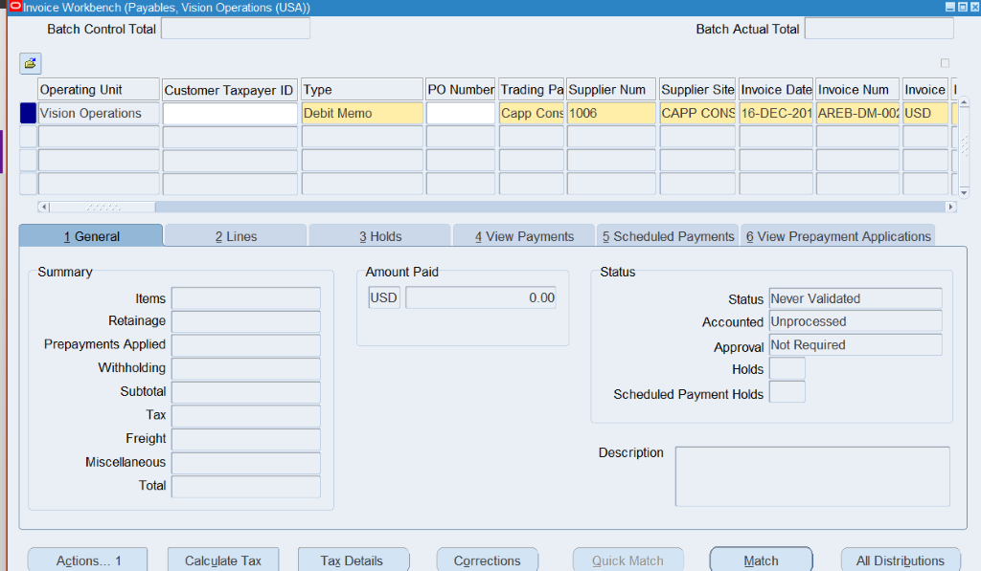

1. Invoice Amount MUST be a NEGATIVE VALUE for Debit memo

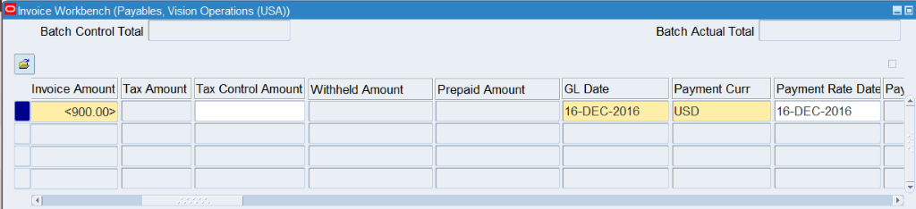  
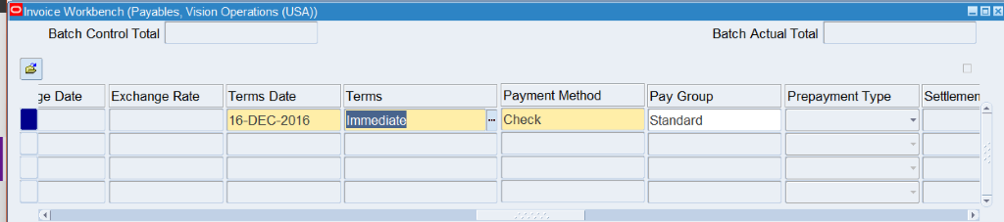  
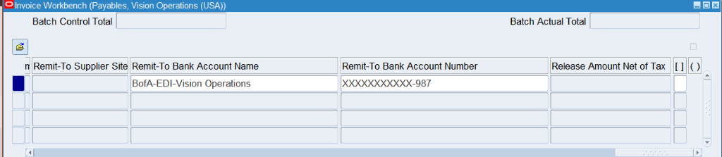

1. Go to Lines Table and insert the mandatory fields and flexfields. Make sure the amount matches the amount from the header table.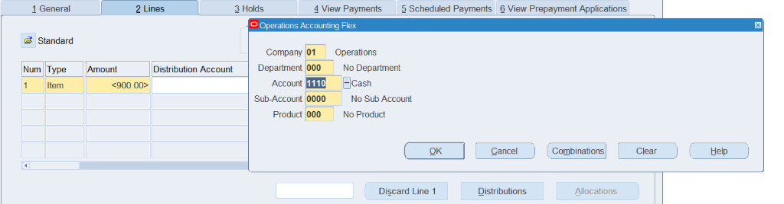
2. Click ‘Calculate Tax’ to insert tax amount

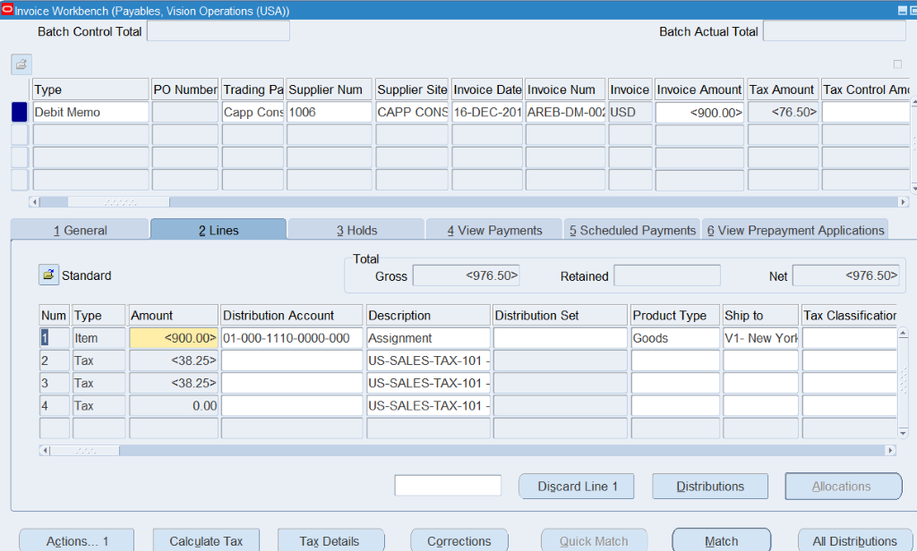

1. Tax will automatically be added to header
2. In the Header field, update the Invoice Amount to reflect post-tax total.  
   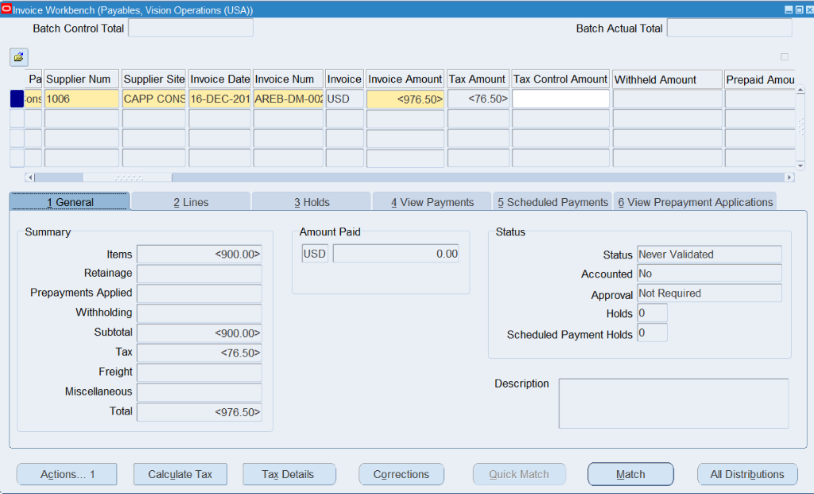
3. If all the Values are correct – Click on Actions – Checkmark “Validate” -- and click “OK” to Validate.  
   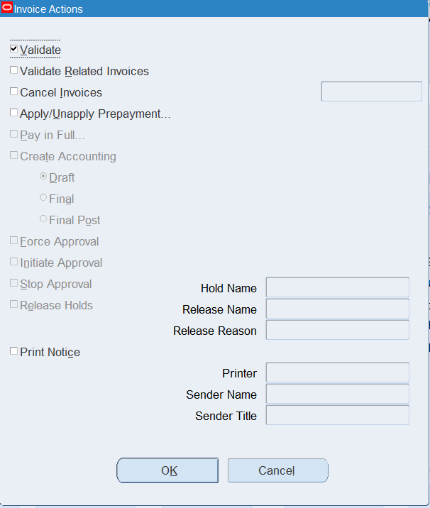
4. Once successfully validated, the status will be changed to “Validated”  
   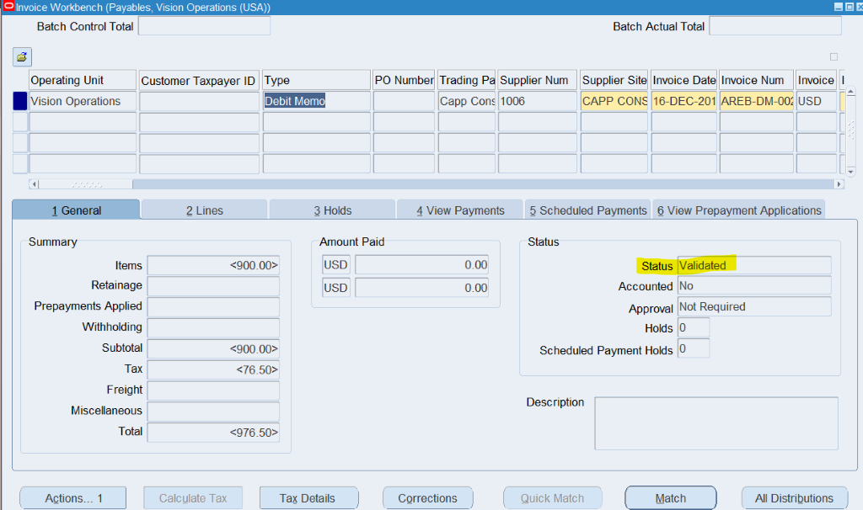
5. Click “Actions”, checkmark “Create Accounting” and “final post” to post it to the ledger.  
   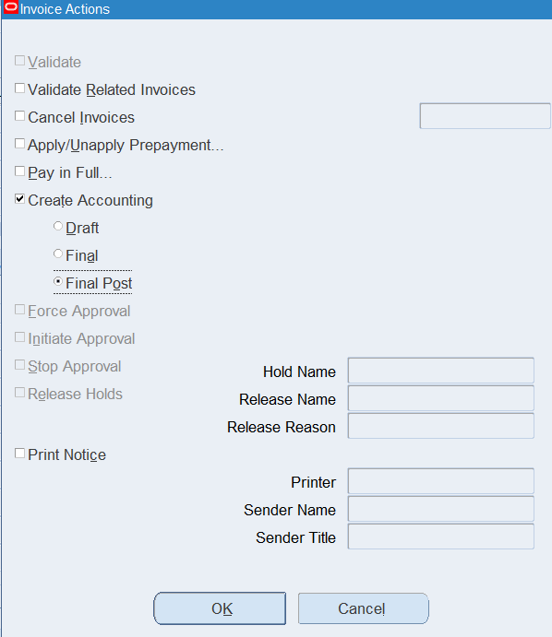

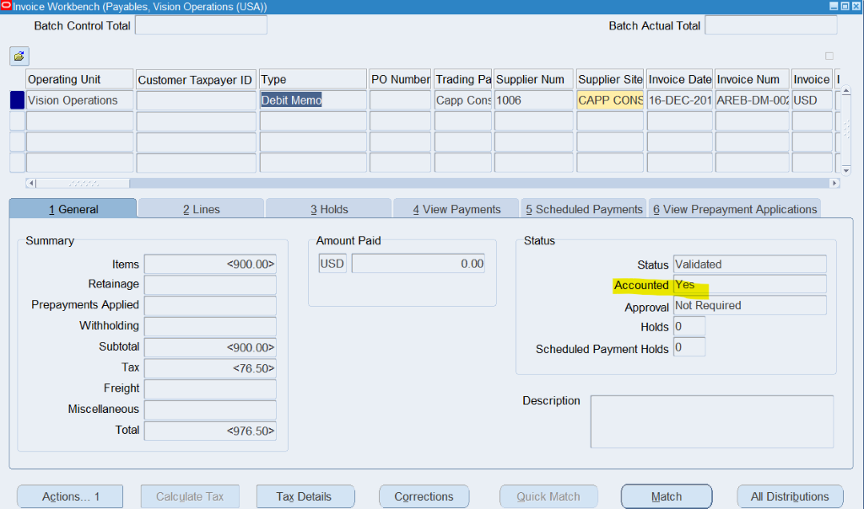

1. **Create a Credit Memo** (Validate & Create accounting) .. Explain each & every step with screen shot.
2. Navigate to Oracle EBS Payables > Invoices > Entry
3. Once form is opened, begin filling out header level information.
4. Type, Trading Partner, Supplier Num, Supplier Site, Invoice Date, Invoice Num, Invoice currency, Invoice Amount, GL date, Payment Currency, Terms date, Terms, and Payment method are the mandatory header level fields
5. Under “Type” Select “Credit Memo”

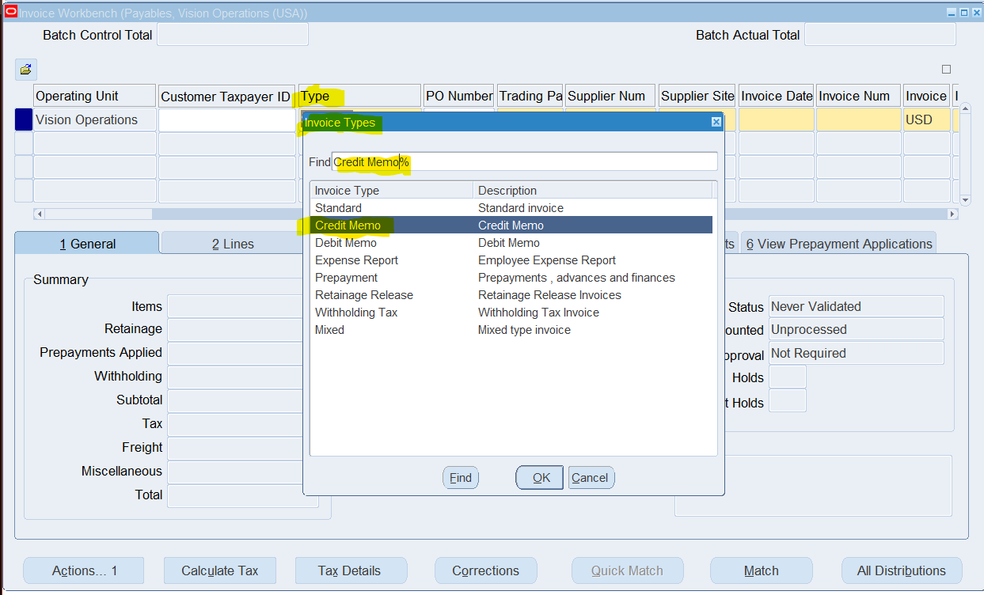

1. Invoice Amount MUST be a NEGATIVE VALUE for Credit memo

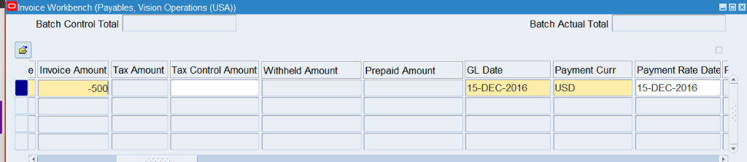

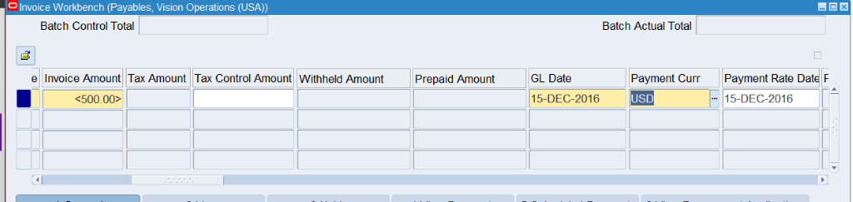

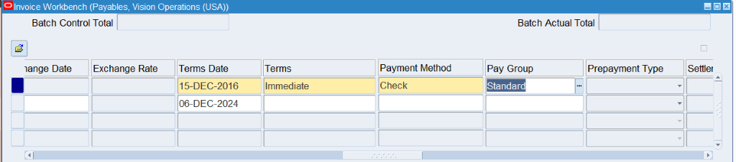

1. Go to Lines Table and insert the mandatory fields and flexfields. Make sure the amount matches the amount from the header table.

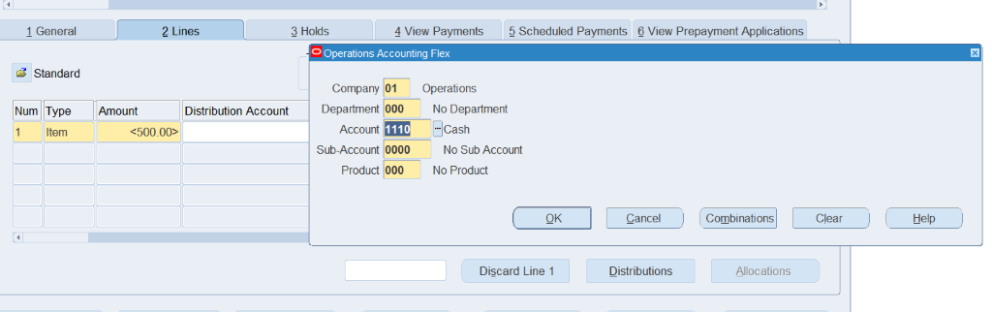

1. Click ‘Calculate Tax’ to insert tax amount

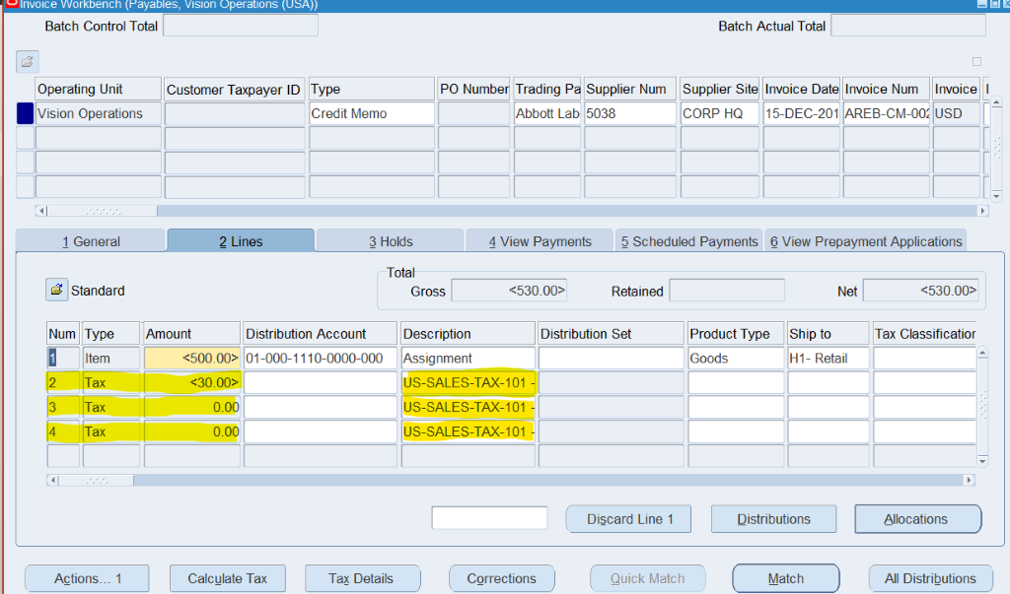

1. Tax will automatically be added to header  
   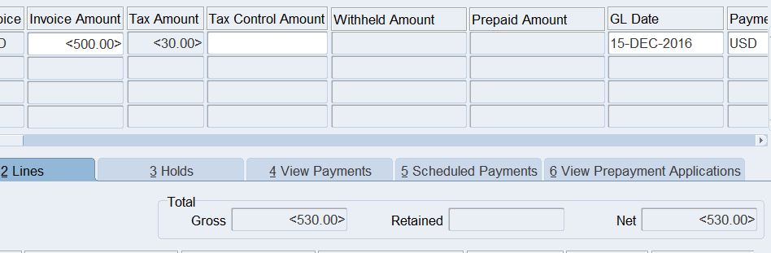
2. In the Header field, update the Invoice Amount to reflect post-tax total.

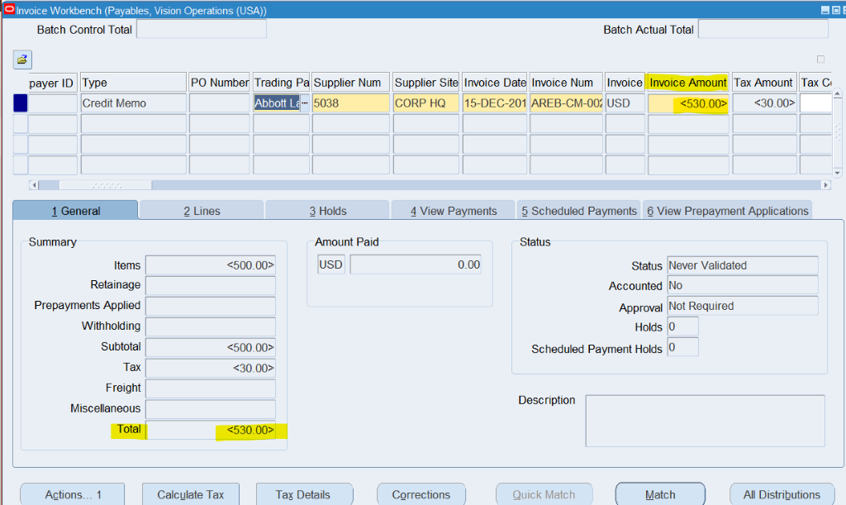

1. If all the Values are correct – Click on Actions – Checkmark “Validate” -- and click “OK” to Validate.

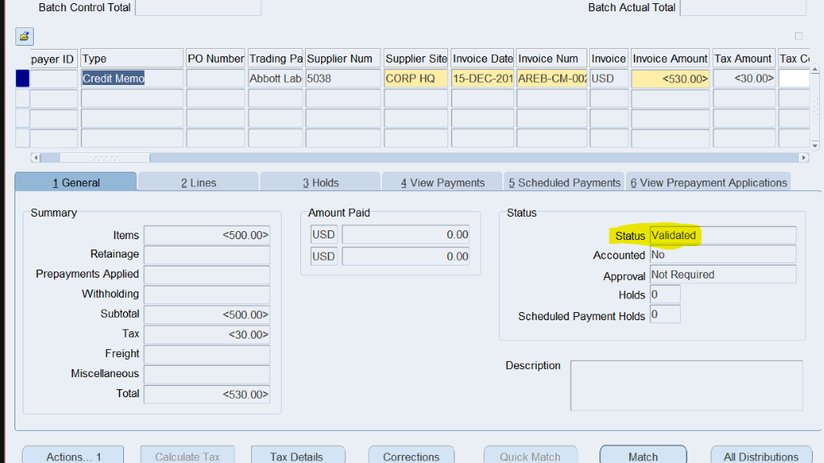

1. Once successfully validated, the status will be changed to “Validated”
2. Click “Actions”, checkmark “Create Accounting” and “final post” to post it to the ledger.

  
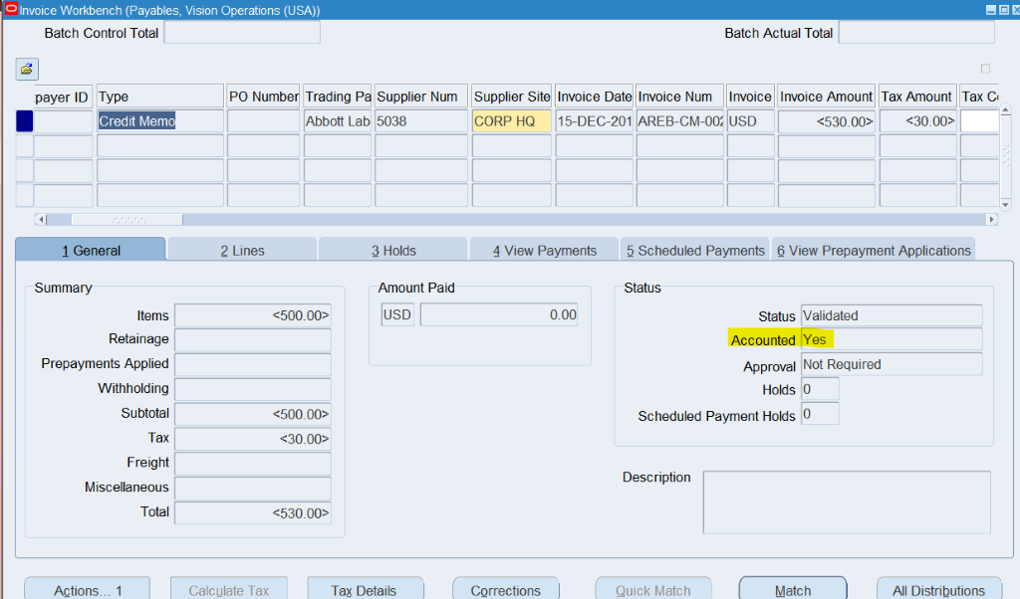

1. **Query a PO based Invoice & check the Po match details.**
2. Navigate to Oracle EBS Payables > Invoices > Entry
3. Once form is opened, refer to the “PO Number” Tab in the header level

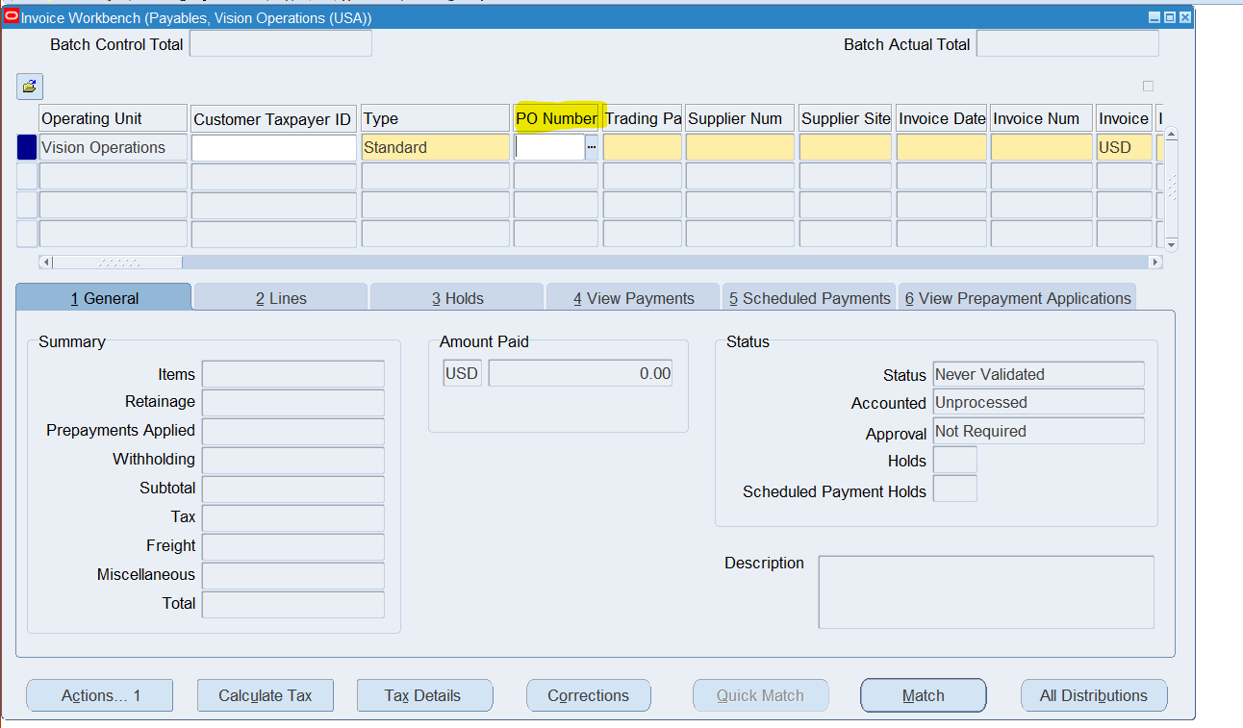

1. Within the “PO Number Tab” Query an invoice that has a PO Number.

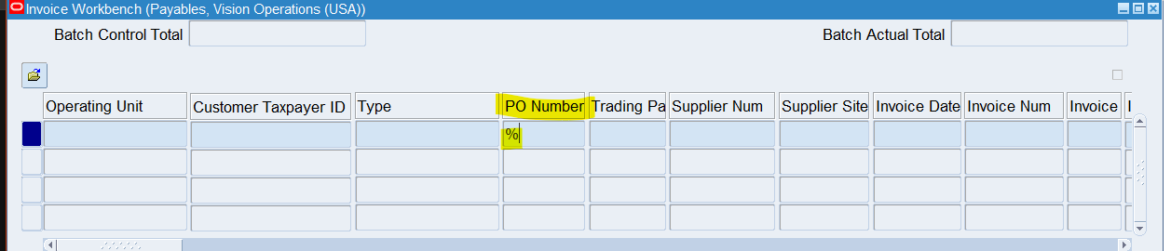

1. The results will include any Invoice that has a valid PO Number and the associated number (EX: 4806)

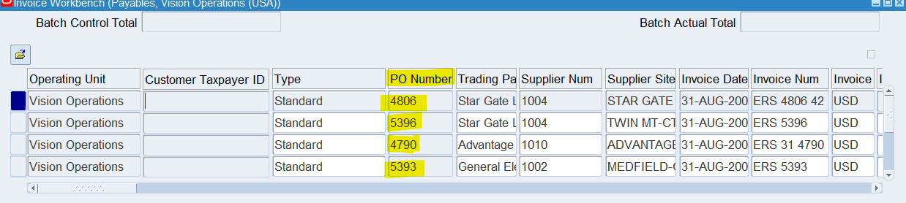

1. Change Responsibility to “Purchasing, Vision Operations (USA)
2. Navigate to the form: Purchasing > Purchase Orders > Purchase Orders Form

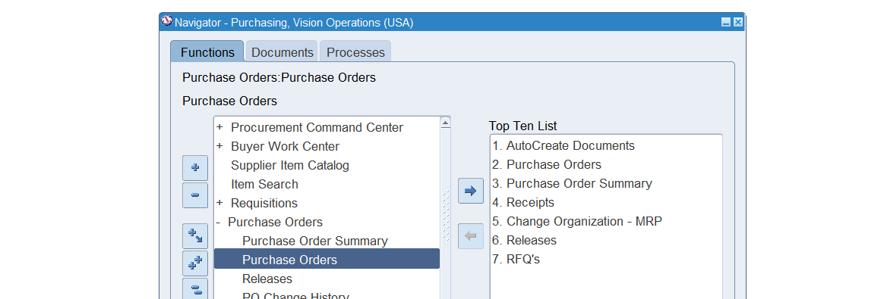

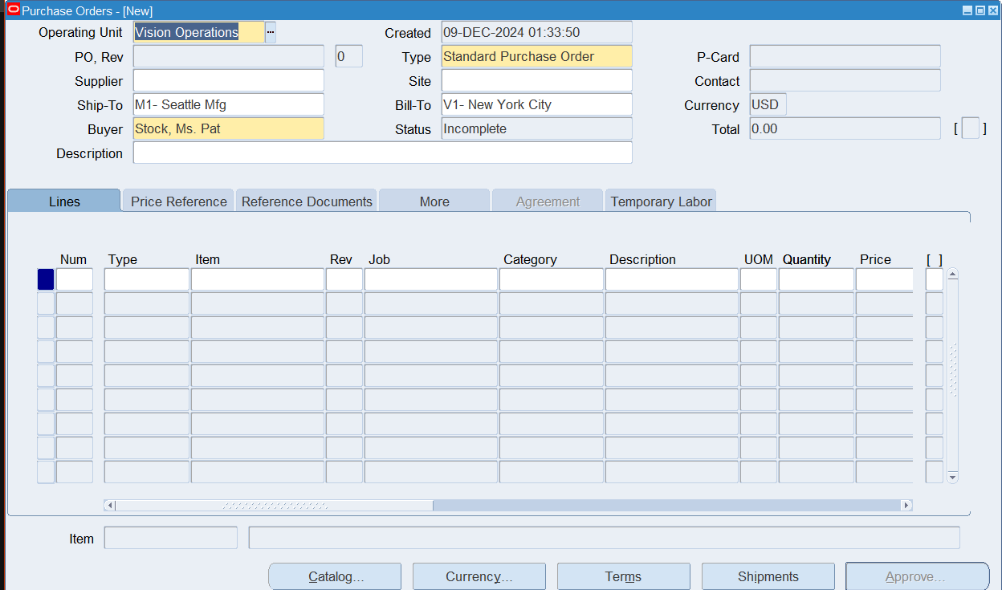

1. Query the “ PO” based on the “Invoice”. Use the PO number listed on the invoice. (EX: 4806)

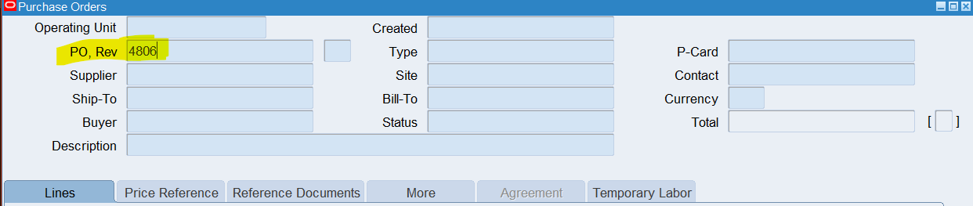

1. View the results that match the invoice.

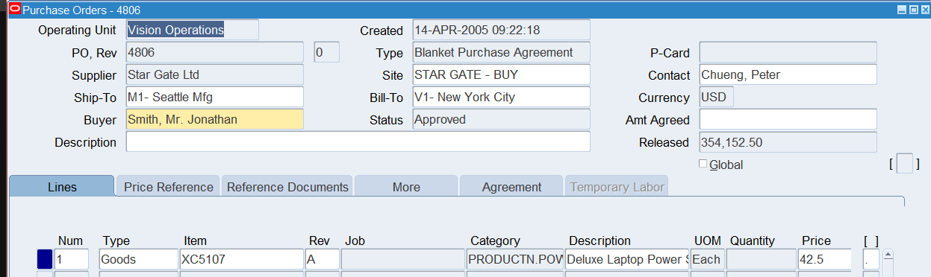

1. **Create a PRE-Payment Invoice [Temporary].**
2. Navigate to Oracle EBS Payables > Invoices > Entry
3. Once form is opened, begin filling out header level information.
4. Under “Type” Select “Prepayment”

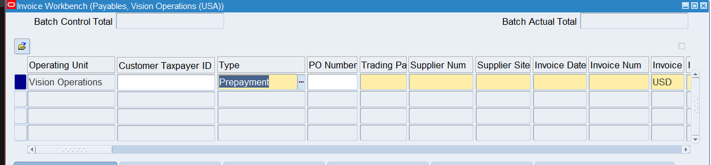

1. Continue filling out Trading Partner, Supplier Num, Supplier Site, Invoice Date, Invoice Num, Invoice currency, Invoice Amount, GL date, Payment Currency, Terms date, Terms, and Payment (mandatory header level fields)

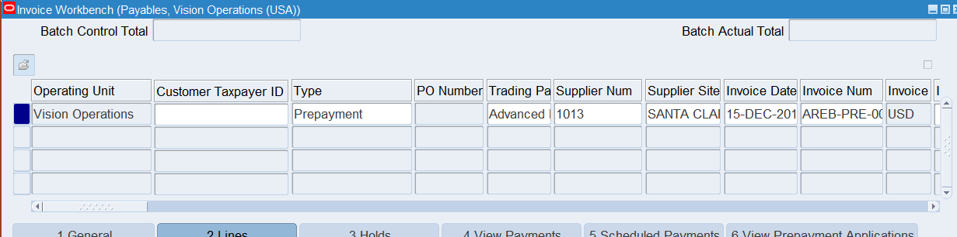

1. Make sure “Prepayment type” field is “Temporary”

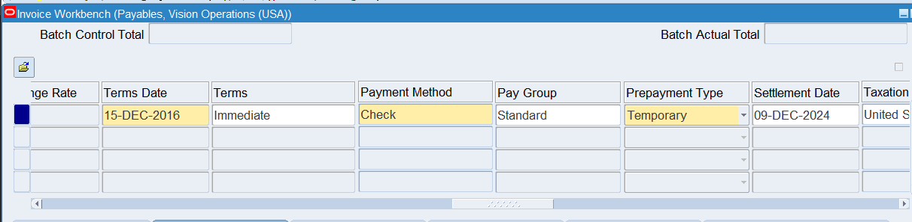

1. **Fill out Line Level information**

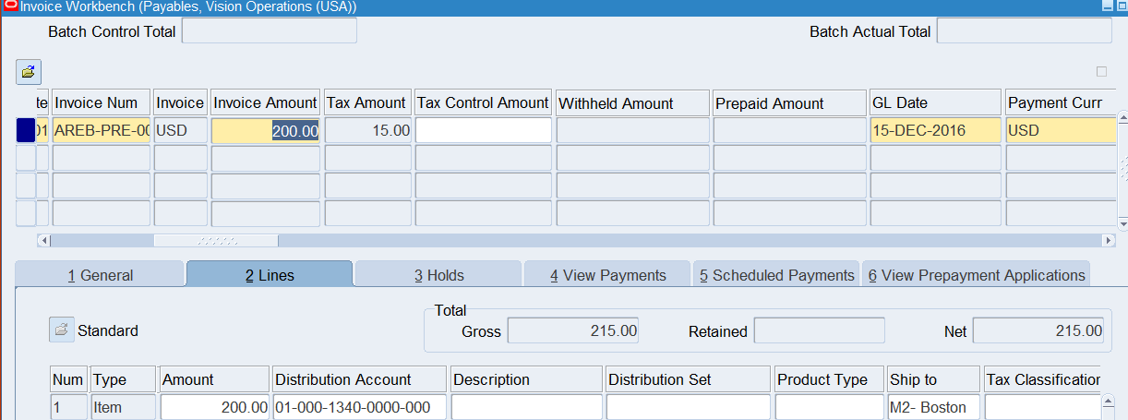

1. **Calculate Tax**

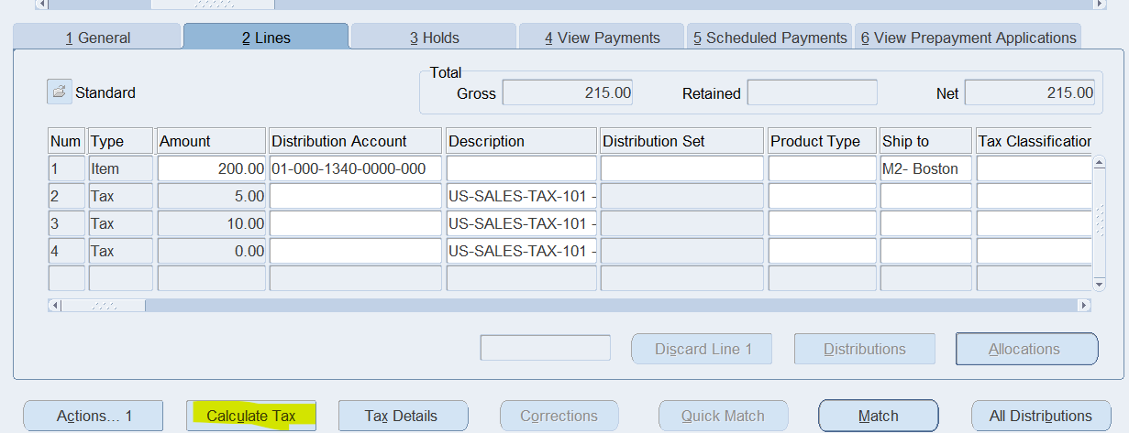

1. **Change Invoice amount to reflect post-tax total.**

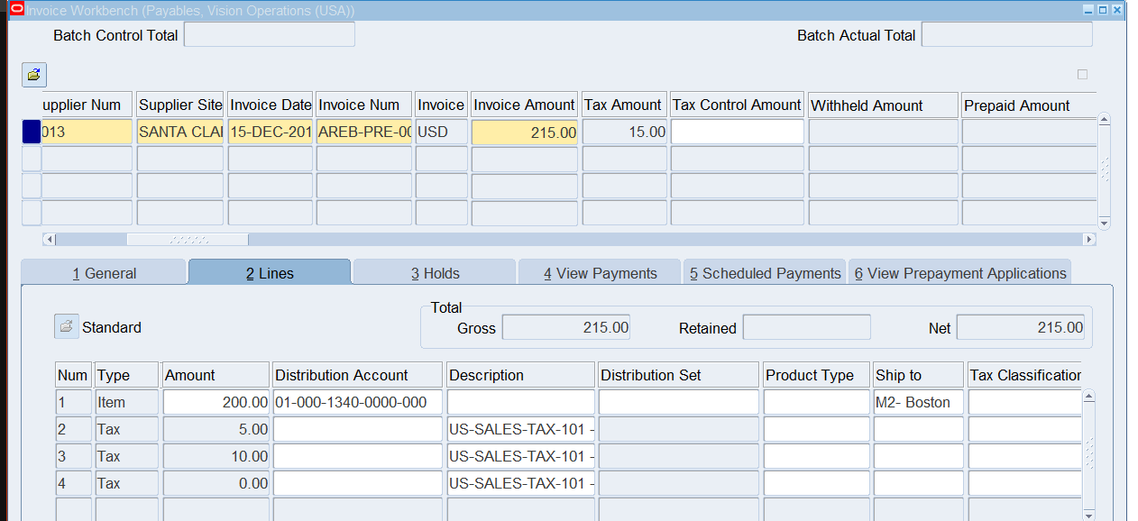

1. **Validate the invoice.**

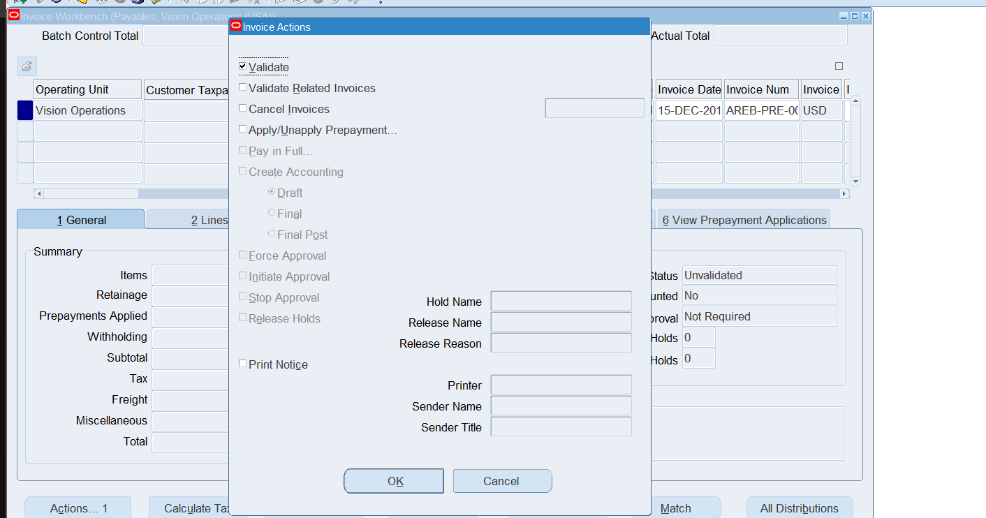

1. **Status will change to “Unpaid”**

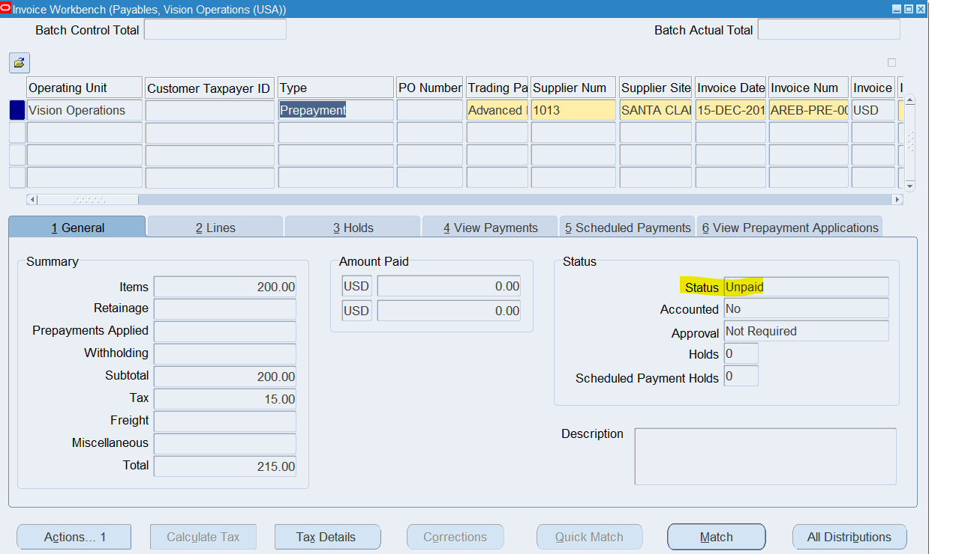

1. **Make single Payment for Standard Invoice** 
   * Navigate to the **Payments** window.
   * Create a payment for the invoice
2. Navigate to Oracle EBS Payables > Invoices > Entry
3. Once form is opened, query your Standard Invoice.

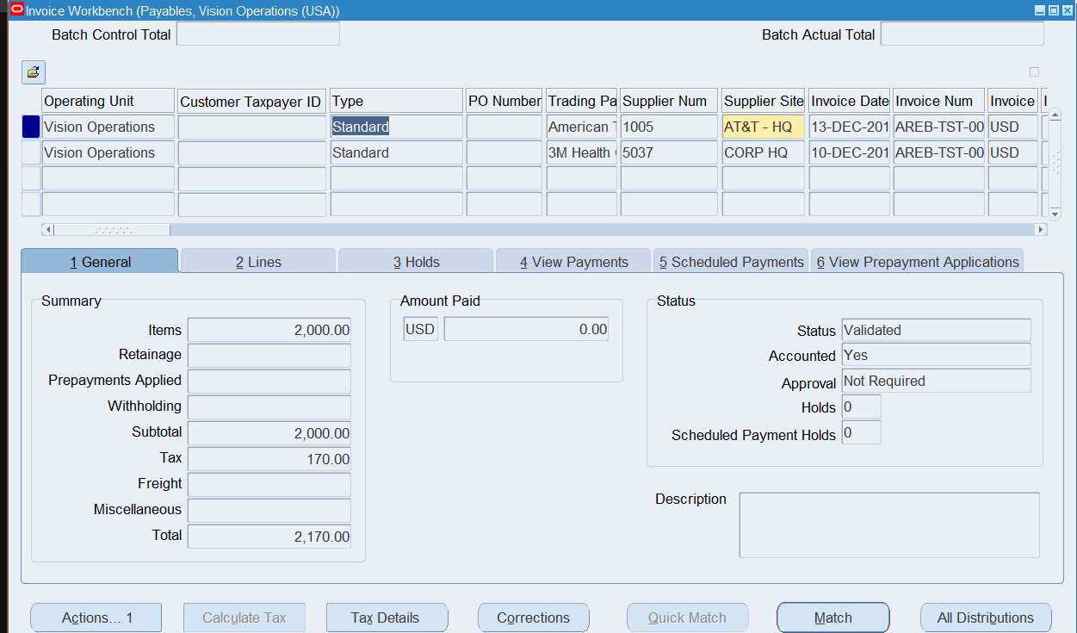

1. Click Actions > Pay in Full >OK. This will redirect you to the Payments Form

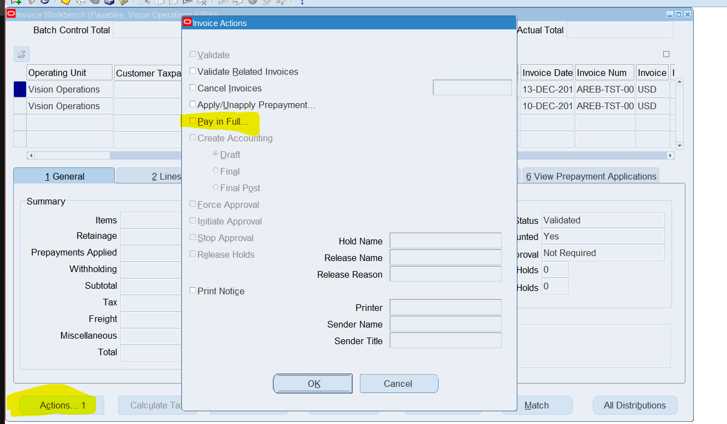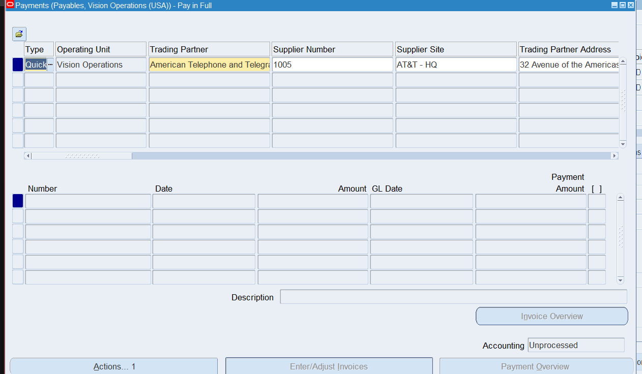

1. Make sure that the date is within an Open Period. Enter Mandatory fields Payment Date, Payment Method, Bank account, and Payment process profile. 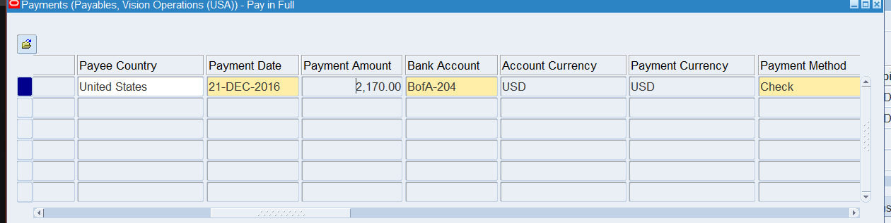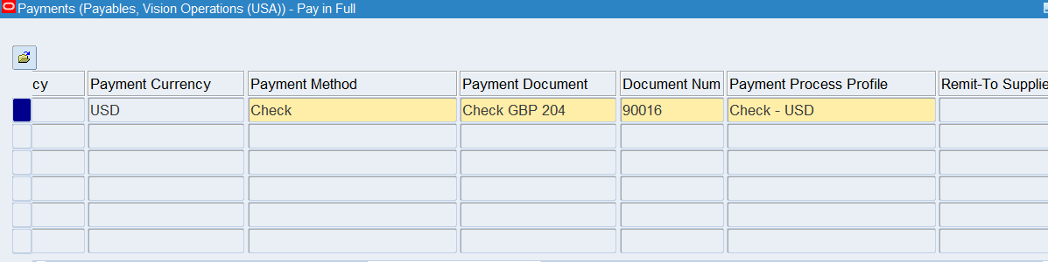
2. To process the payment, select Actions > Create Accounting > Final Post & Print remittance.  
   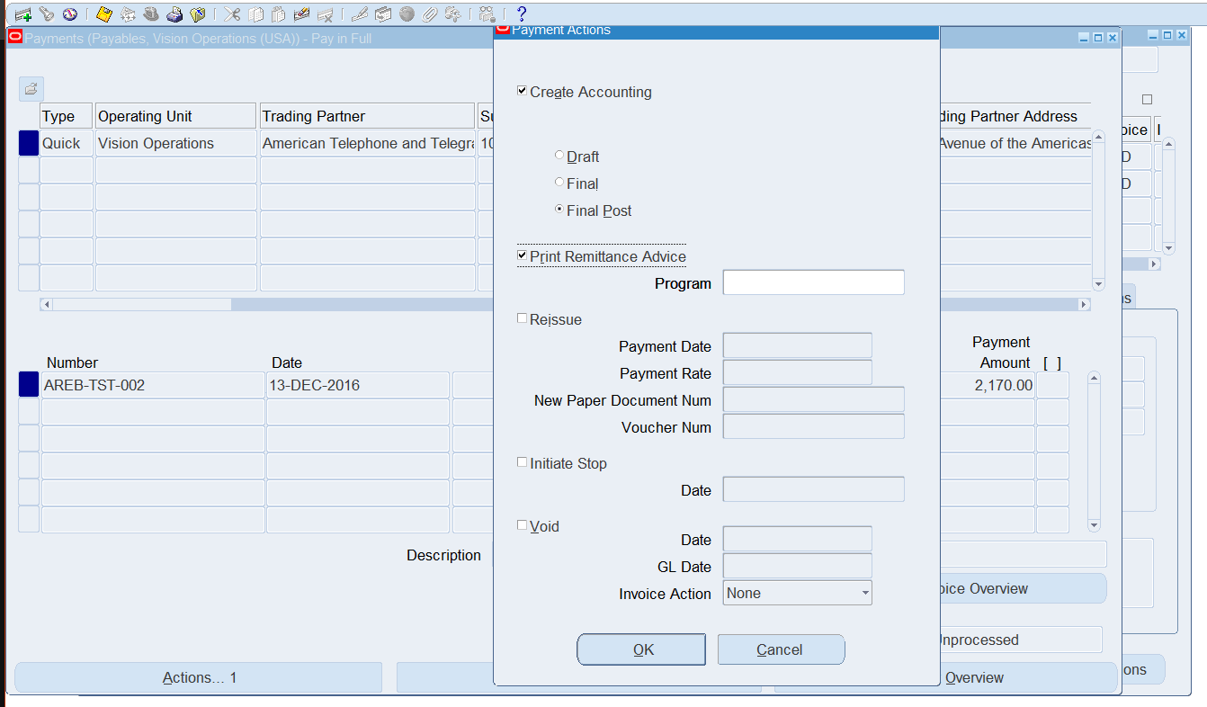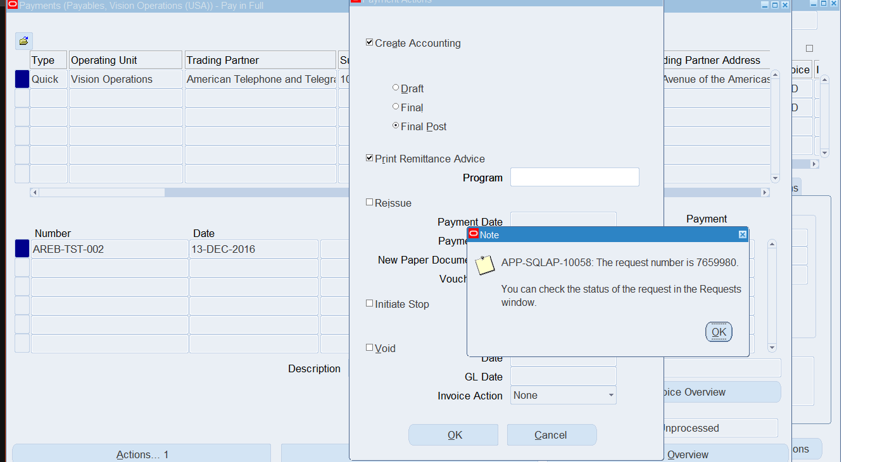
3. Return to General Ledger to view if payment has processed.

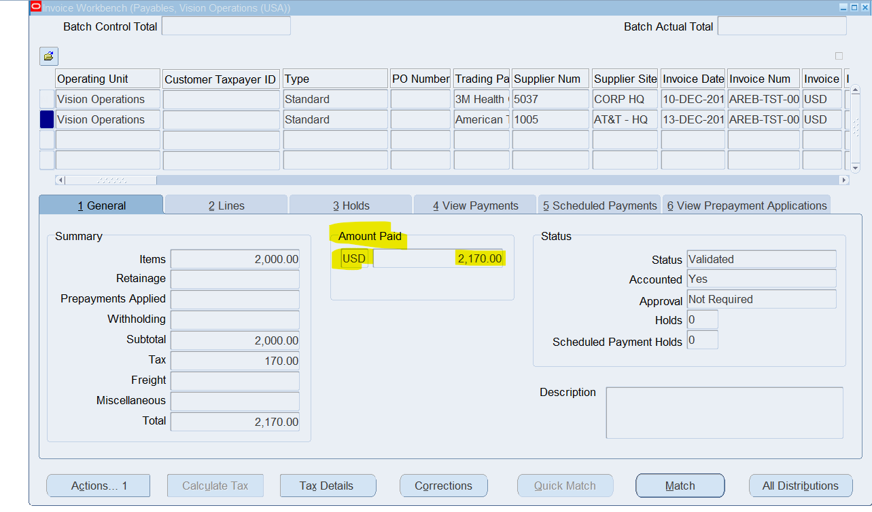

1. **Review Payment Status:**
   * Check the payment status in the **Payments** window.
   * Verify that the payment has been successfully processed and issued.
2. Navigate to Oracle EBS Payables > Invoices > Entry
3. Under “View Payments” Tab, take a note of the “document number” assigned for your payment (EX: 90016)

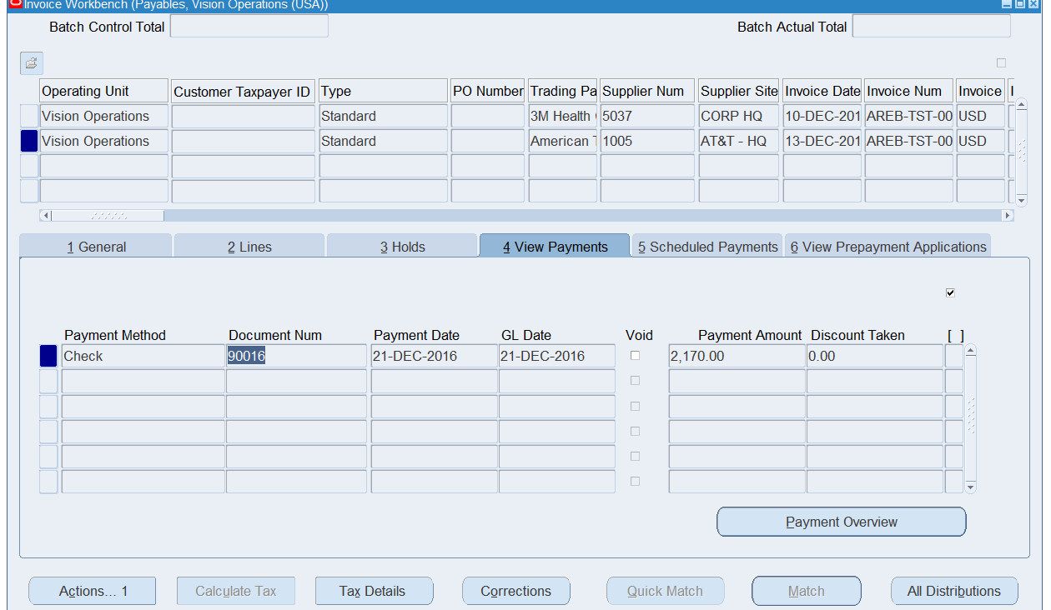

1. Close the form
2. Navigate to Payments form. Payables > Payments > Entry > Payments

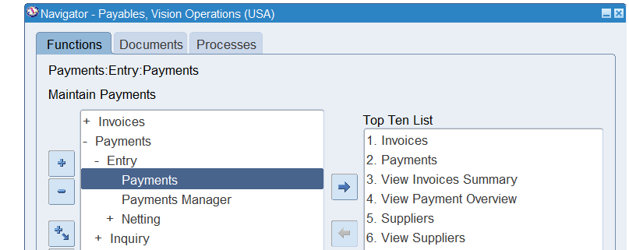

1. Query the Invoice using the “Document Number” (EX:90016)

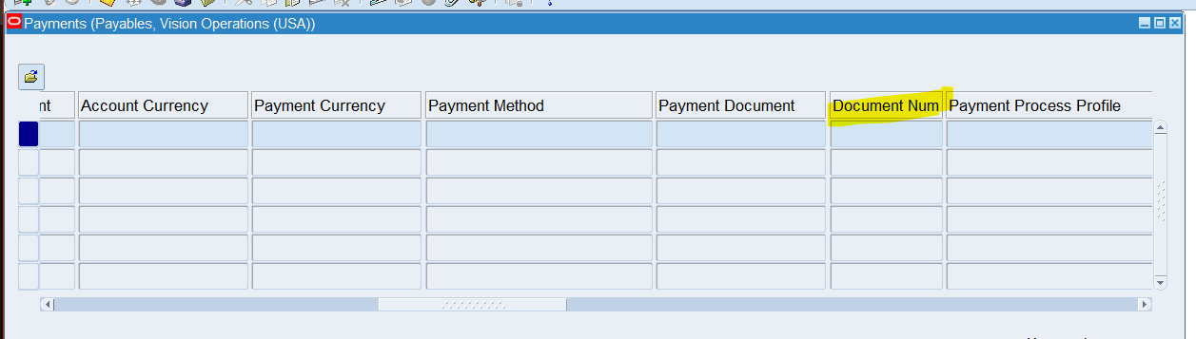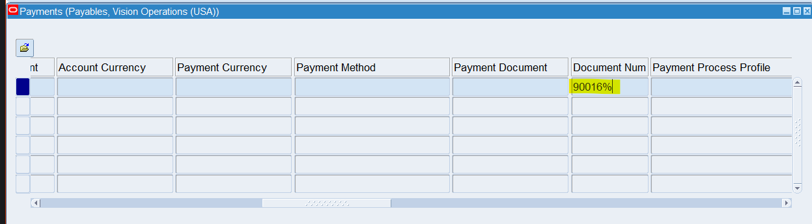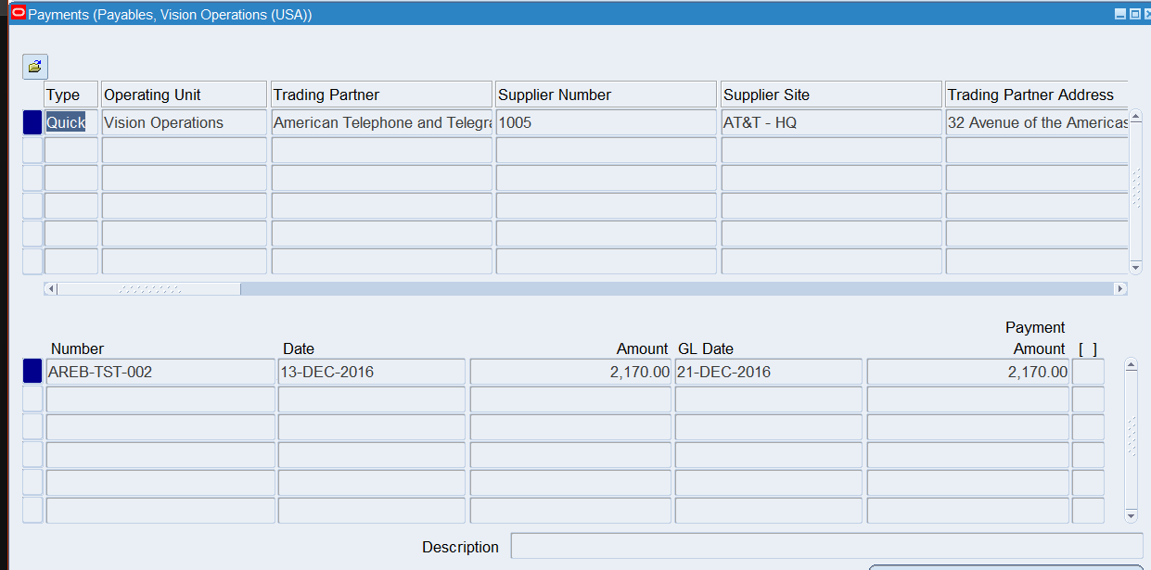

1. Select “Payment Overview” to view additional Details and confirm process. The Accounting should also be listed as processed

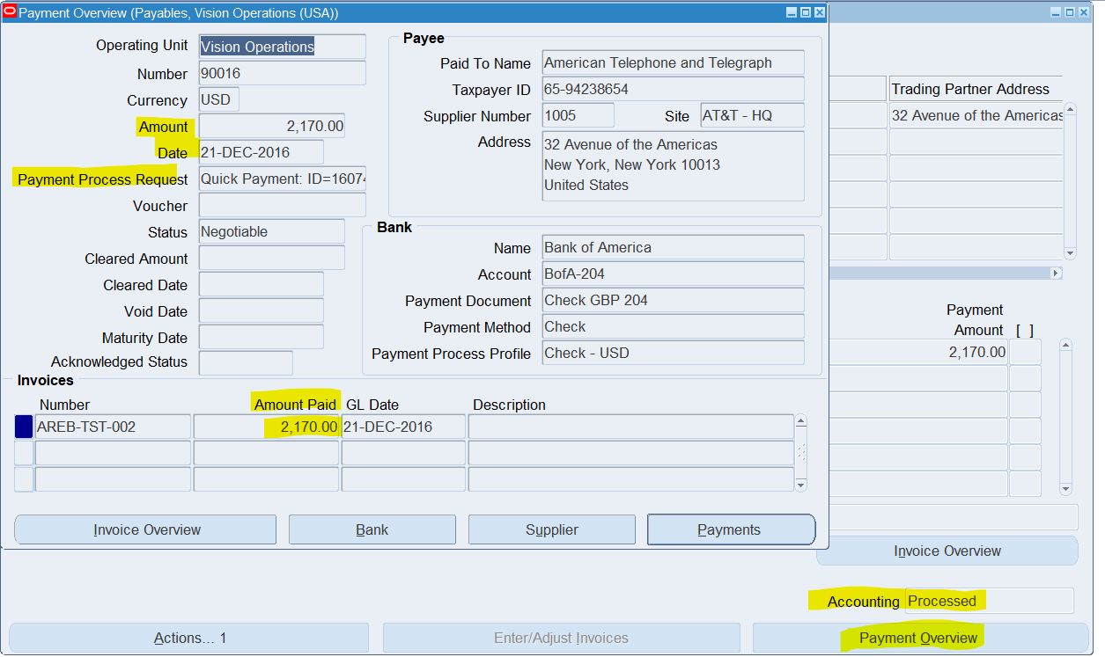

1. **Review the Accounting Entries:**
   * Review the accounting entries for the invoice and payment.
   * Ensure that the correct debits and credits are applied to the appropriate accounts (e.g., Expense and Bank accounts).
2. Navigate to **Payables > Invoices > Entry > Invoices**.
3. Query Invoice

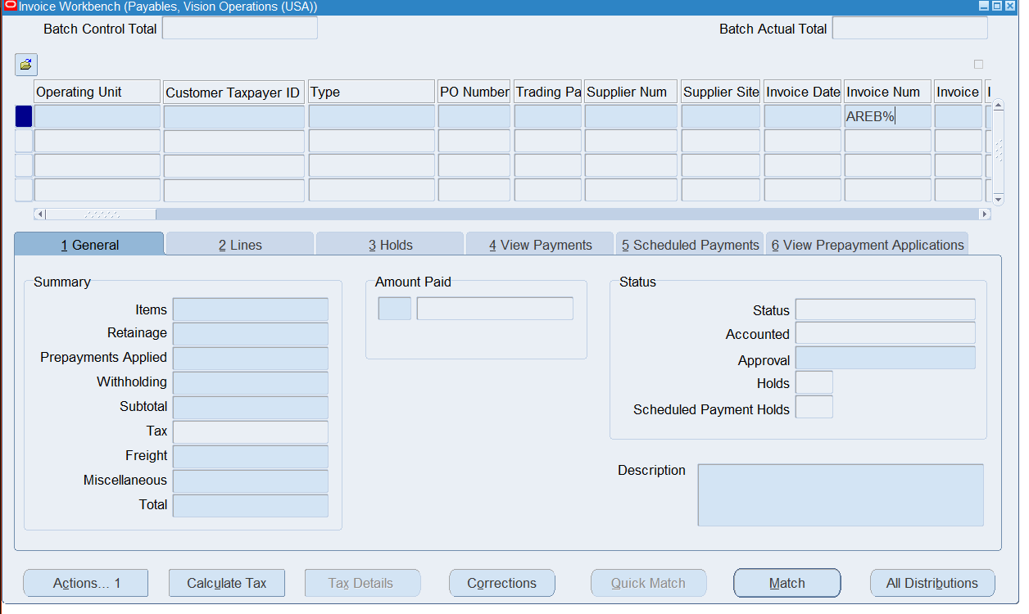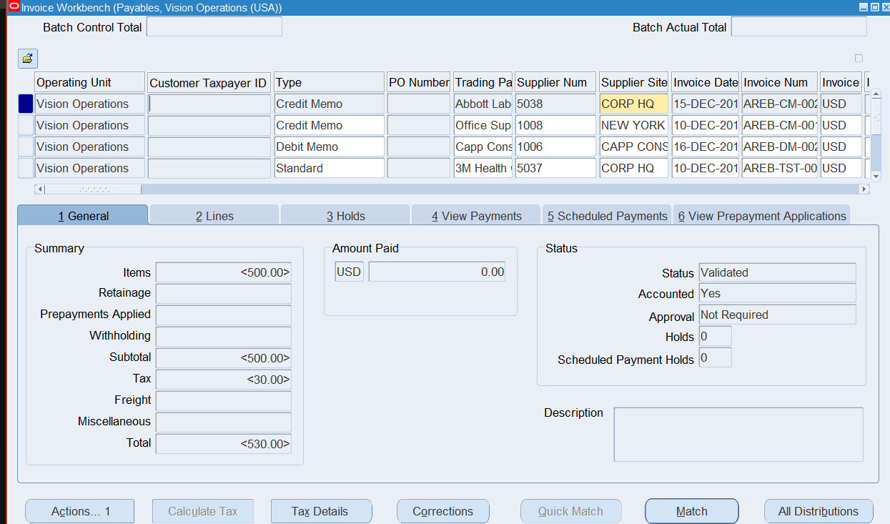

1. Using the toolbar navigate to Tools > View Accounting Events

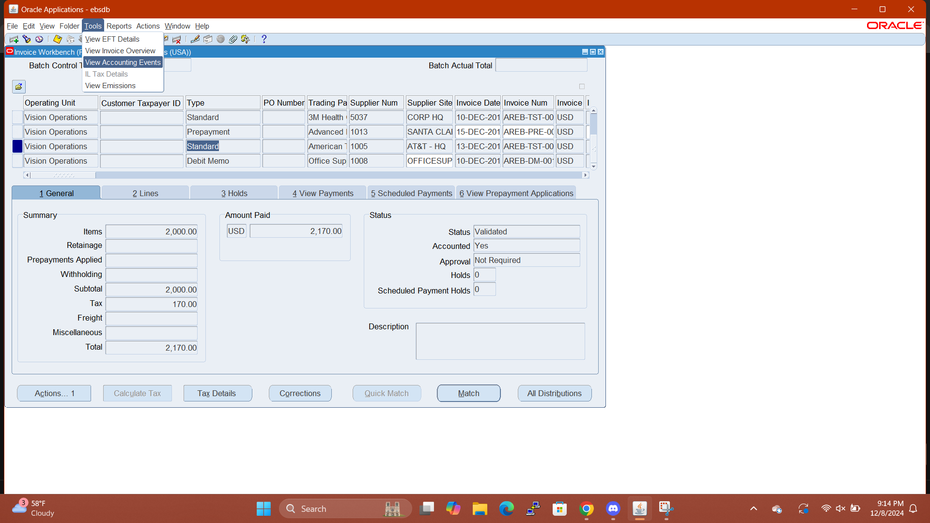

1. This will navigate you to the Accounting Events HTML page

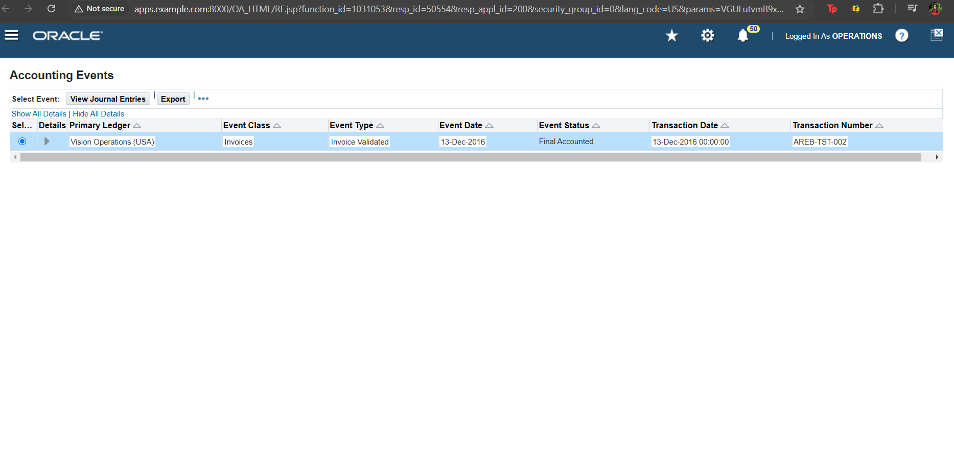

1. After clicking “Show ALL Details” you can view the information.

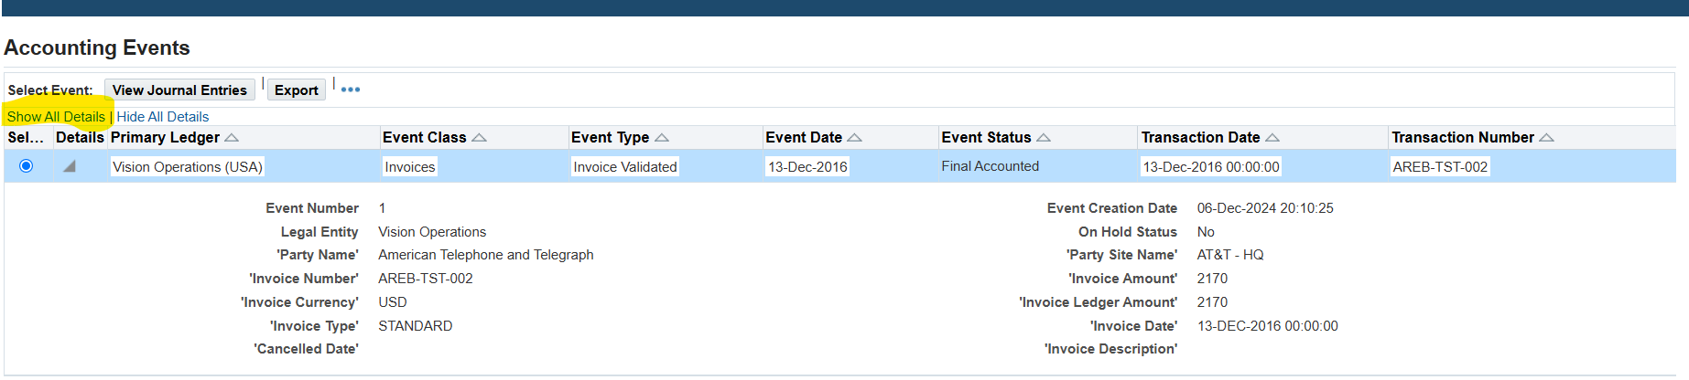

1. **In Invoice Workbench how many types of Invoices are there?**
2. There are 8 Different types of Invoice Types. Standard, Credit Memo, Debit Memo, Expense Report, Prepayment, Retainage Release, Withholding Tax, and Mixed.
3. You can view the difference types of invoices by going to   
   Payables(R) > Invoices > Entry > Invoices. By clicking on “TYPE” you can view the different types of invoices.  
   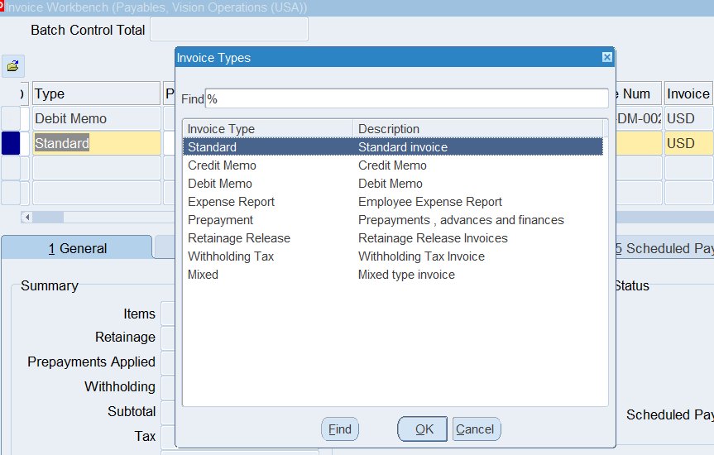
4. **Troubleshoot a Payables Issue: Hold**  
   Invoice line level variances [Hold] Release hold with Invoice Re-Validation
5. An example of an invoice line level Hold is when tax is calculated into the invoice but the total invoice amount is not updated and the user attempts to validate. This creates a hold.

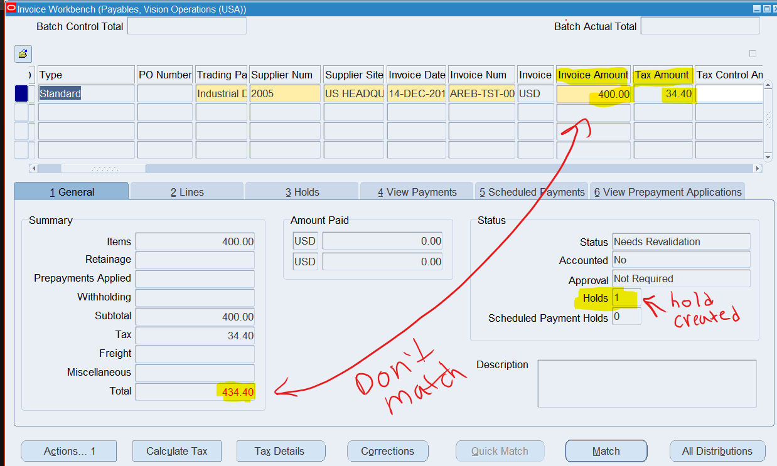

1. The Hold can be further investigated under the “3 . Holds” Tab. In the example below the “hold reason” is listed as “total of invoice” which doesnt match the total. The hold name is “Line Variance”

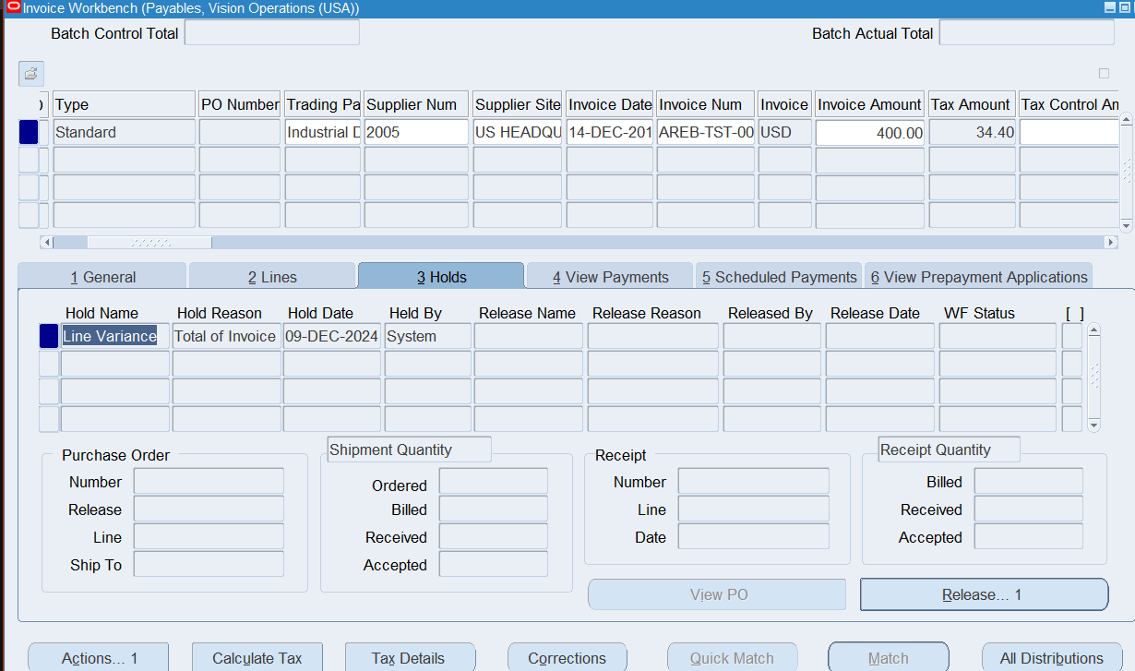

1. This Type of Hold can be removed with Re-Validation. For this example the Invoice Amount must match the total reflected in the General ledger post-tax.

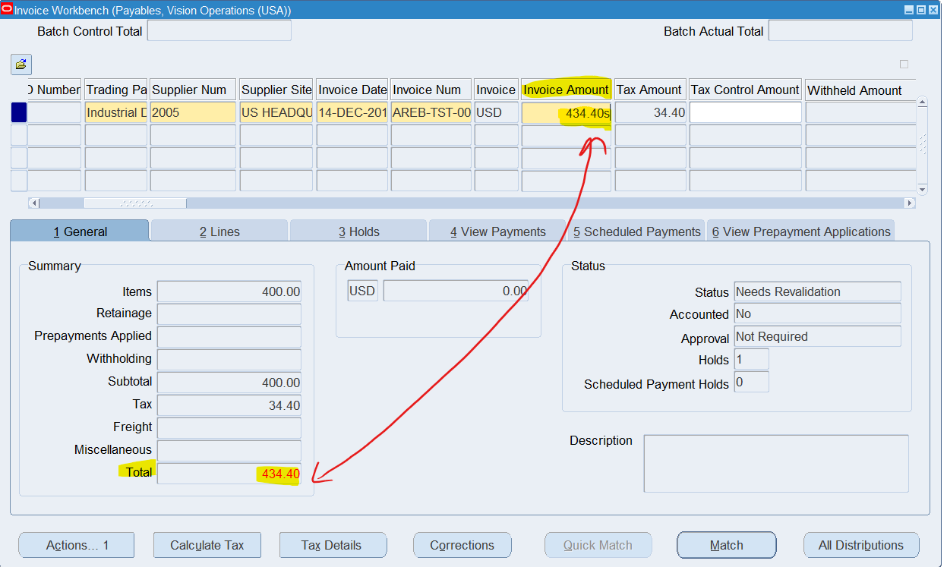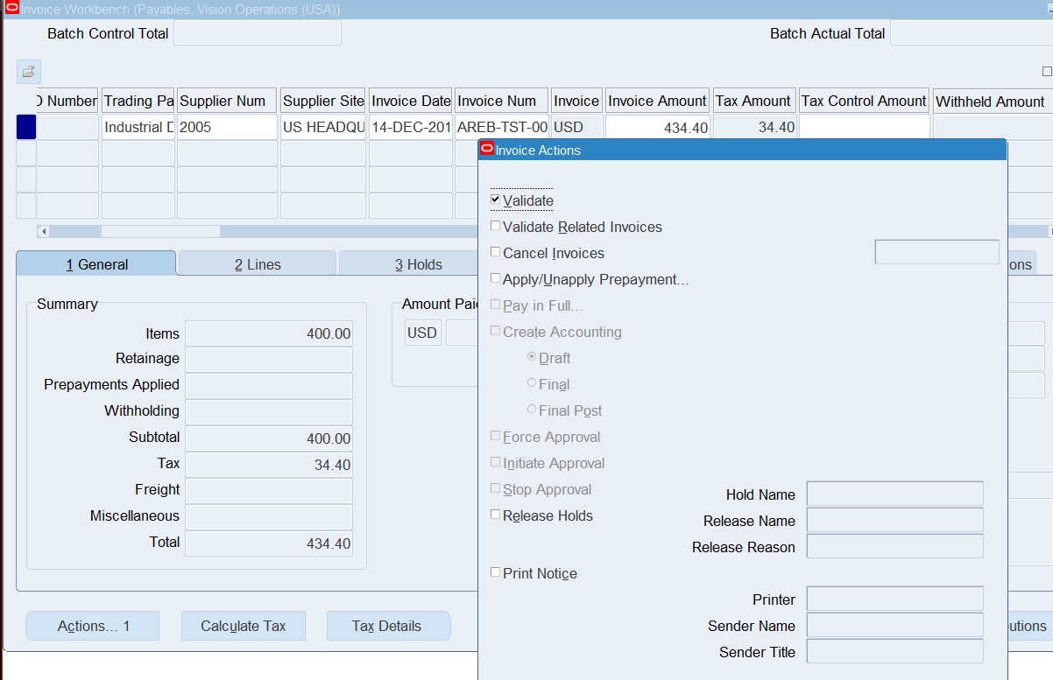

1. By doing so, the hold has been removed and the entry has been validated.

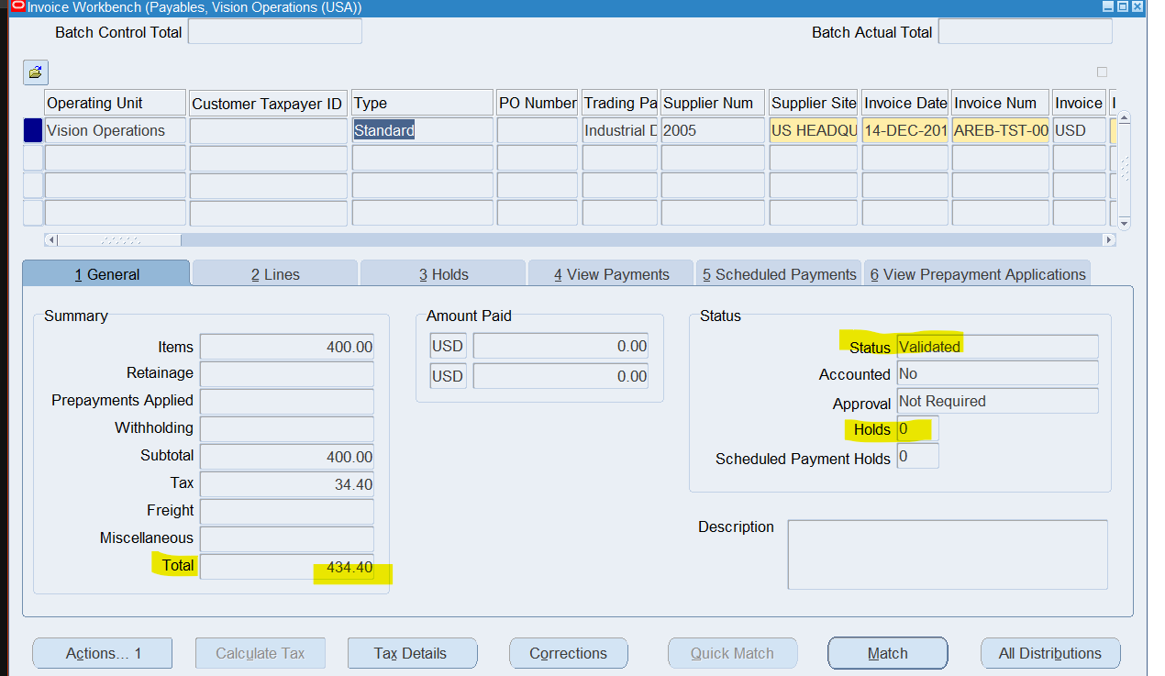

1. Under the “holds” tab, further details can be viewed such as that hold has been released by system

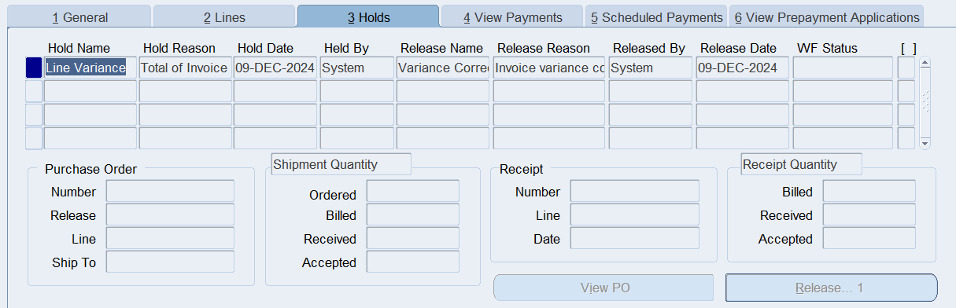

1. **In the PAYMENT Work Bench query the payment Document # (the Payment which you have done for Standard Invoice.**
2. Navigate to Oracle EBS Payables > Invoices > Entry
3. Under “View Payments” Tab, take a note of the “document number” assigned for your payment (EX: 90010)
4. 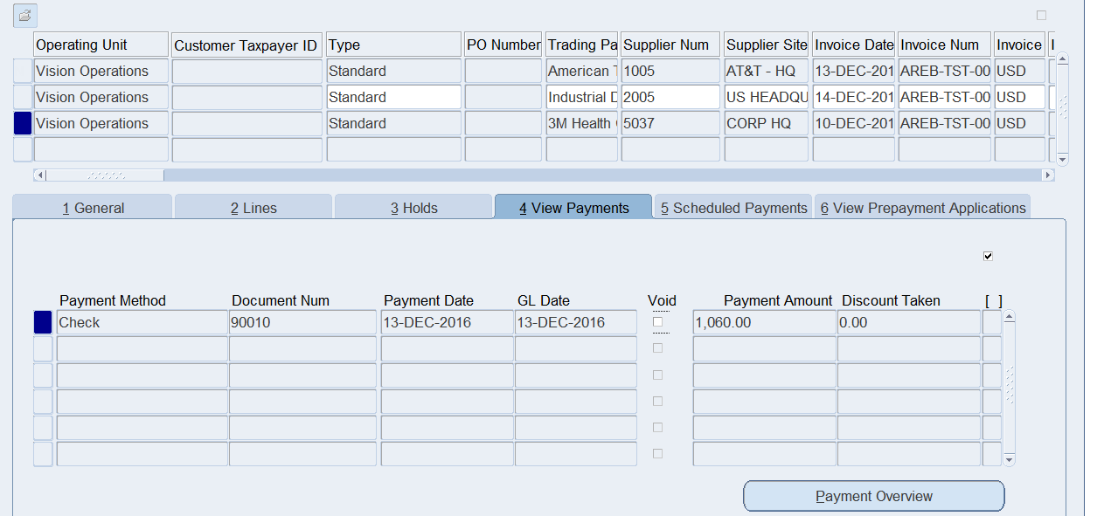
5. Close the form
6. Navigate to Payments Workbench. Payables > Payments > Entry > Payments
7. 
8. Query the Invoice using the “Document Number” (EX:90010)
9. 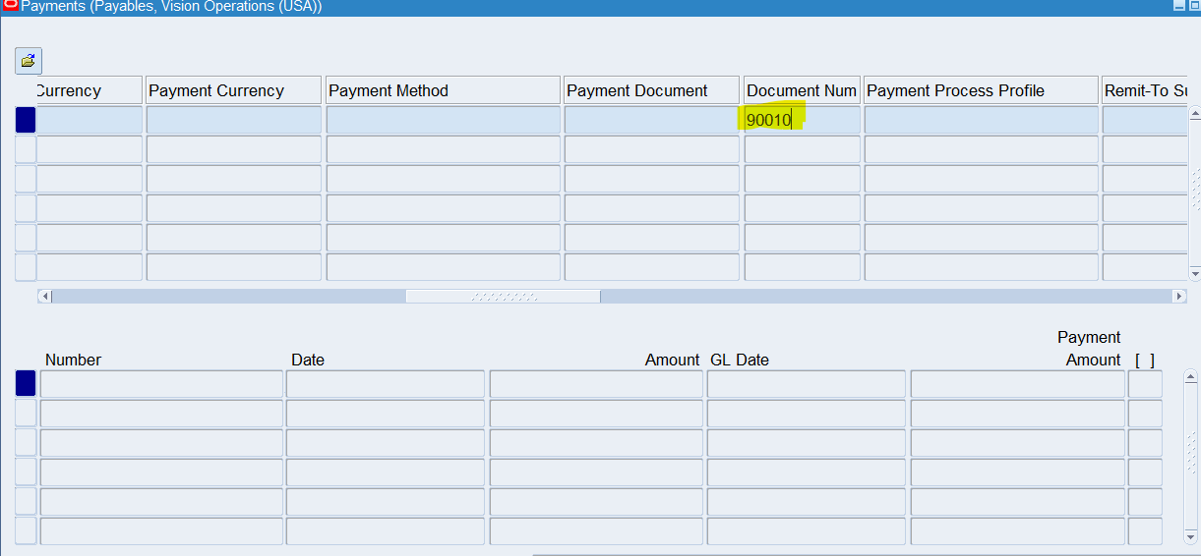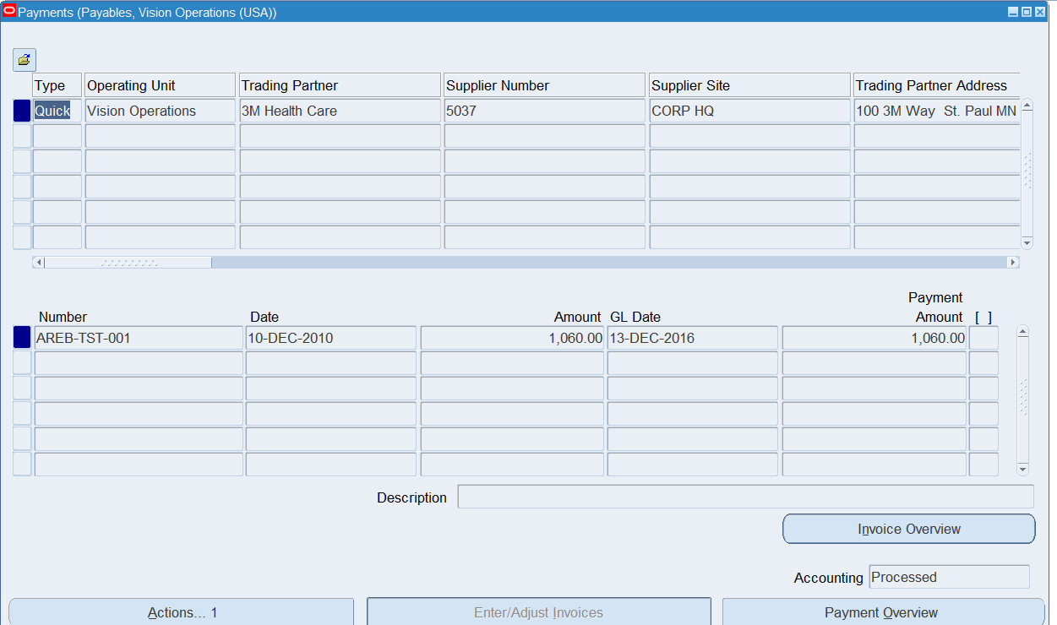
10. **Review the Payment accounting details.**
11. On the same page as the previous example. Click on the Toolbar and navigate to Tools > View Payment Details

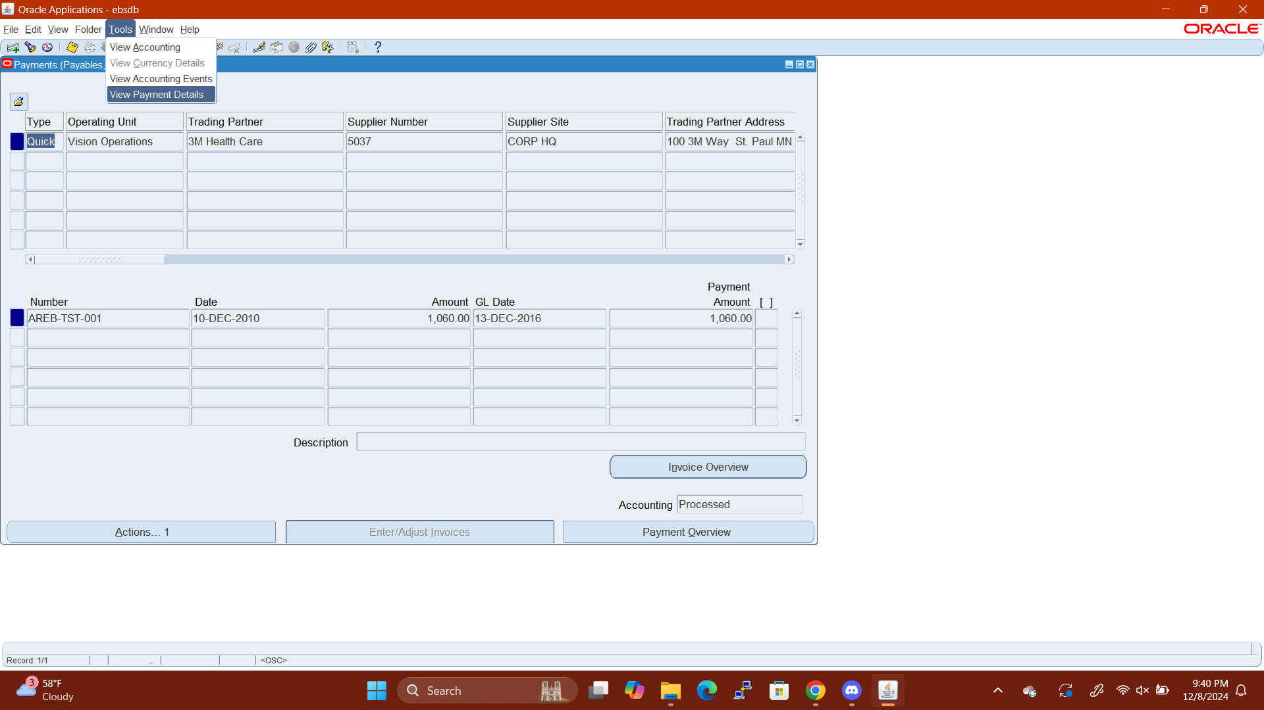

1. The form will redirect to an HTML page

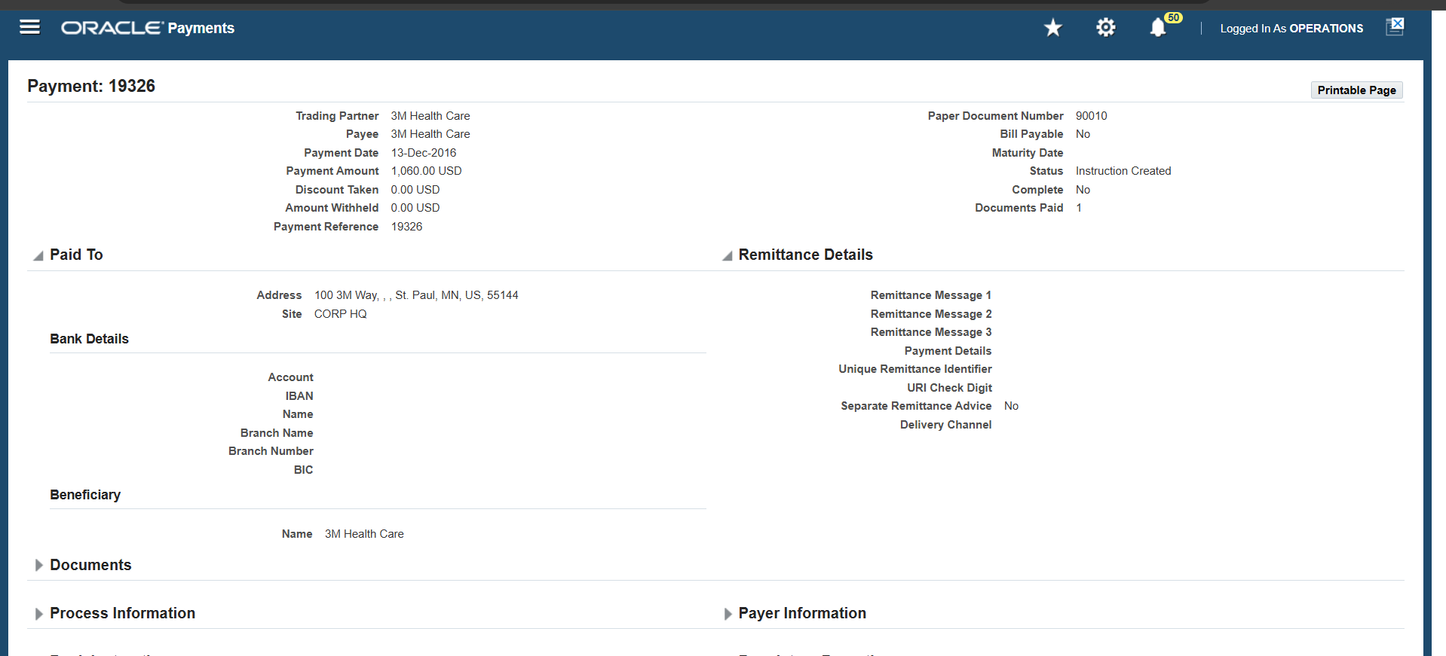

1. Payment details may be reviewed here

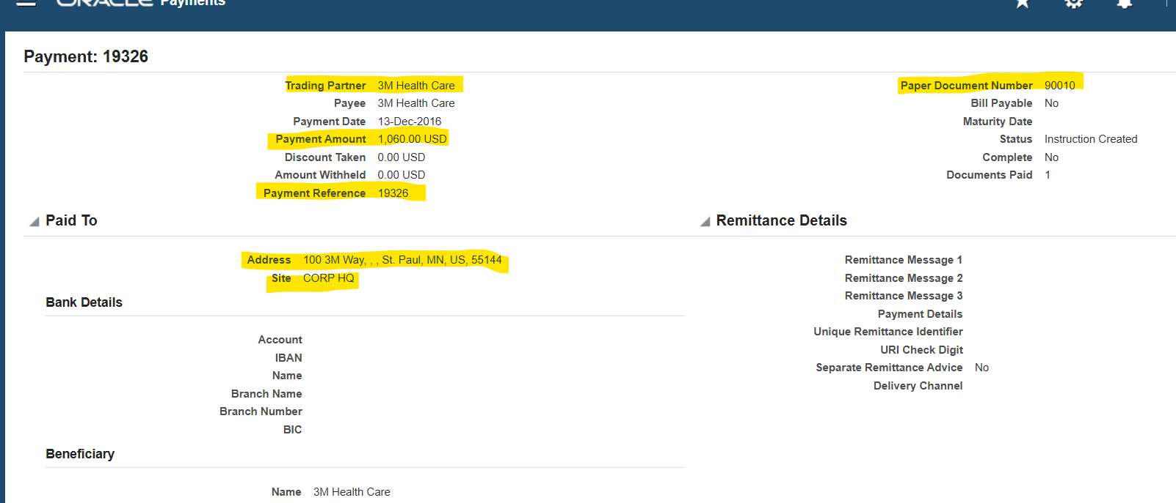

**Cash Management:**

1. **Review the Bank account Details (Disbursement Bank) which you use for Payment.**
2. **Switch Responsibilities to “Cash Management, Vision Operations”**

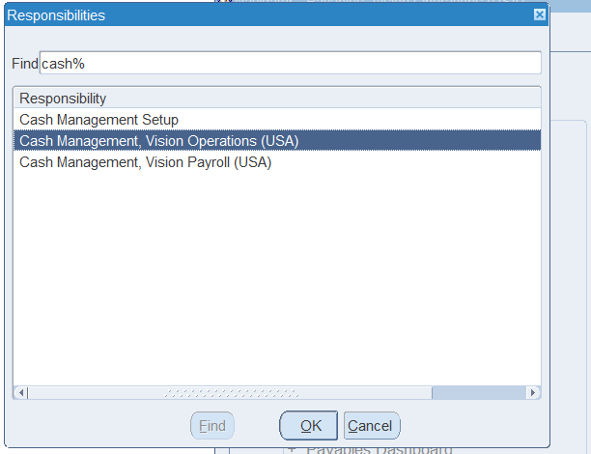

1. Navigate to the following form:   
   cash management >view > bank account 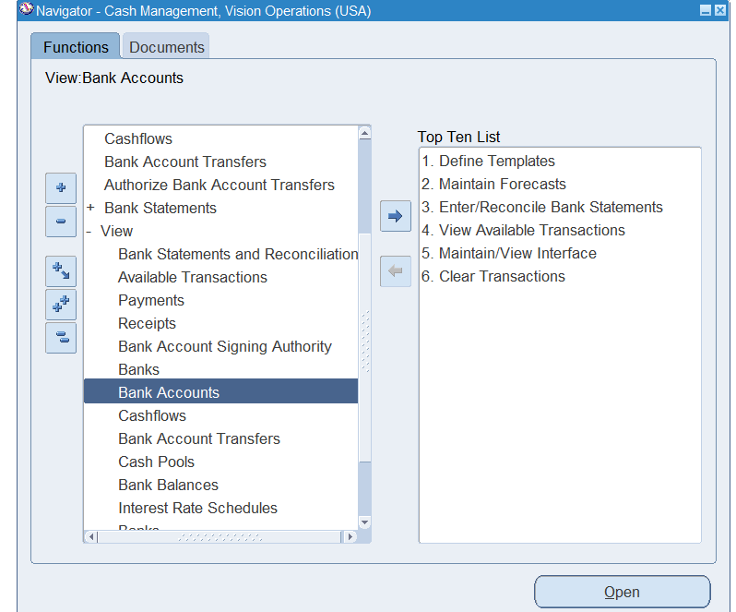
2. This will redirect the form to an HTML page.

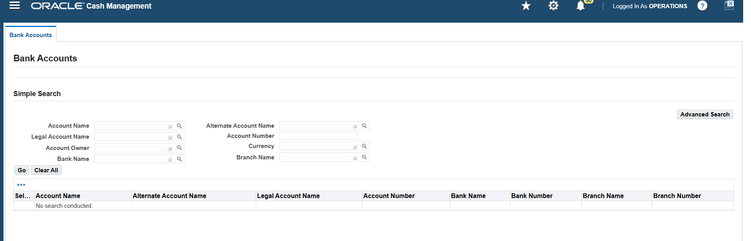

1. Query and Select the bank account which was used for payment.

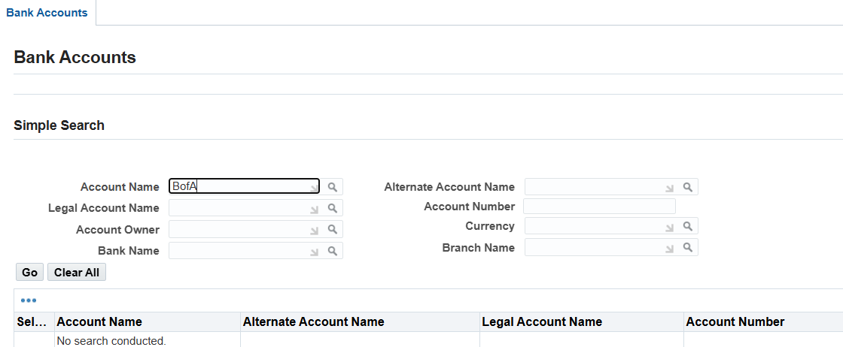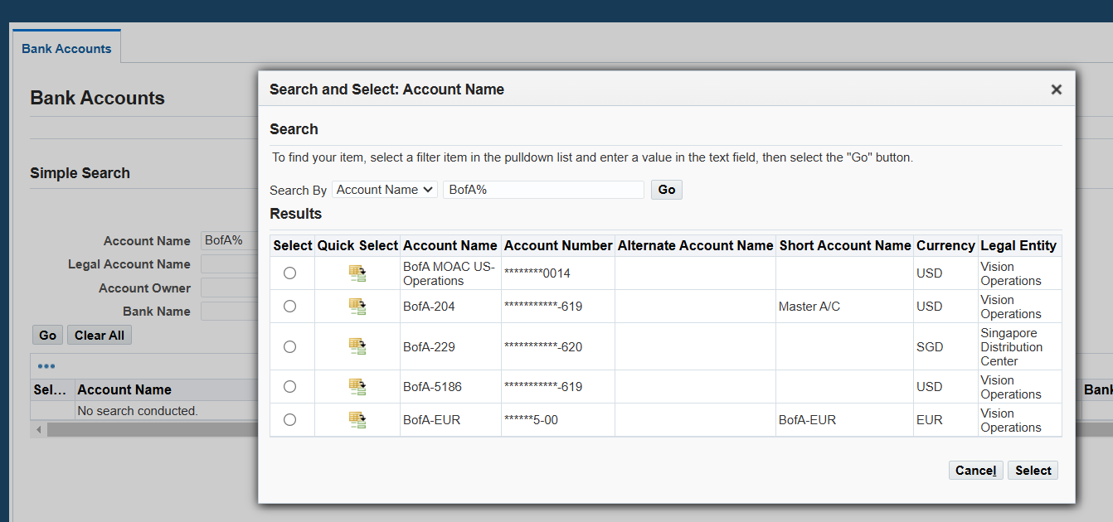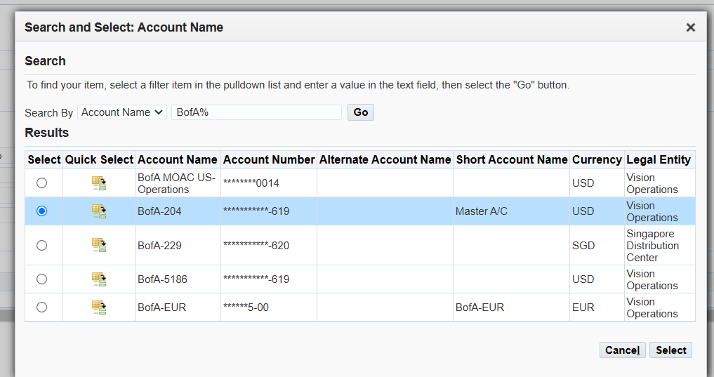

1. Select “GO” and the webpage will find the specific account.

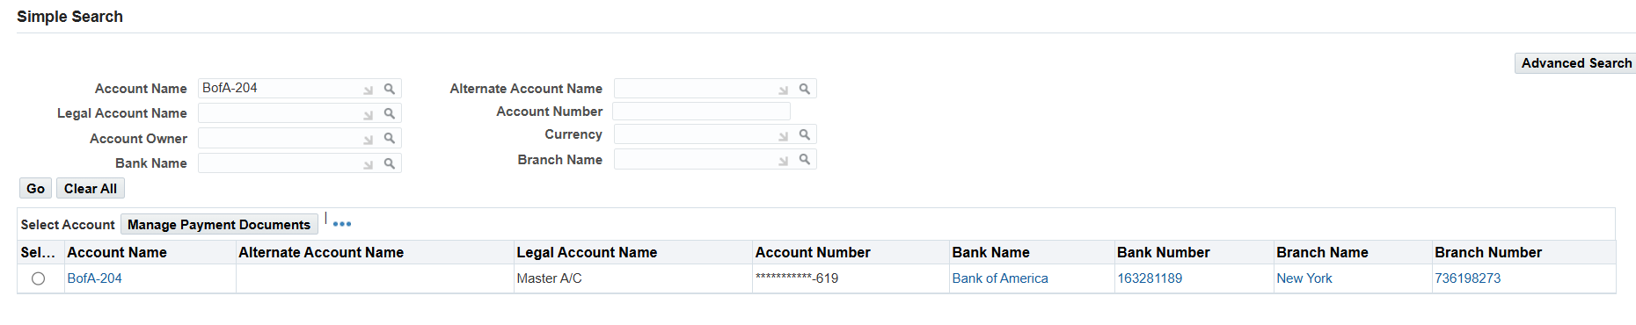

1. Click on hyperlink under account name and the HTML page for the account will open

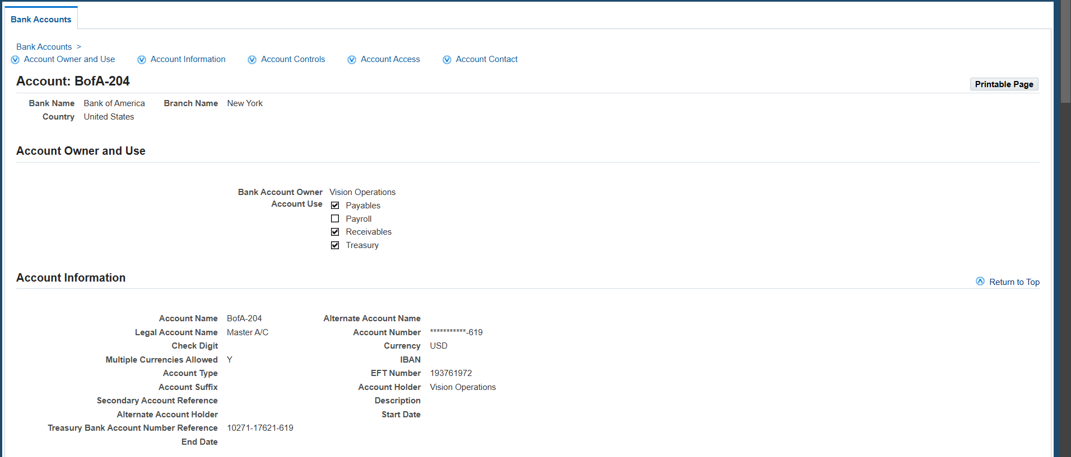

1. Details can be viewed on this page. Information such as Account number, Account Name, Owner, Flexfields, Controls, Contacts, and more.

